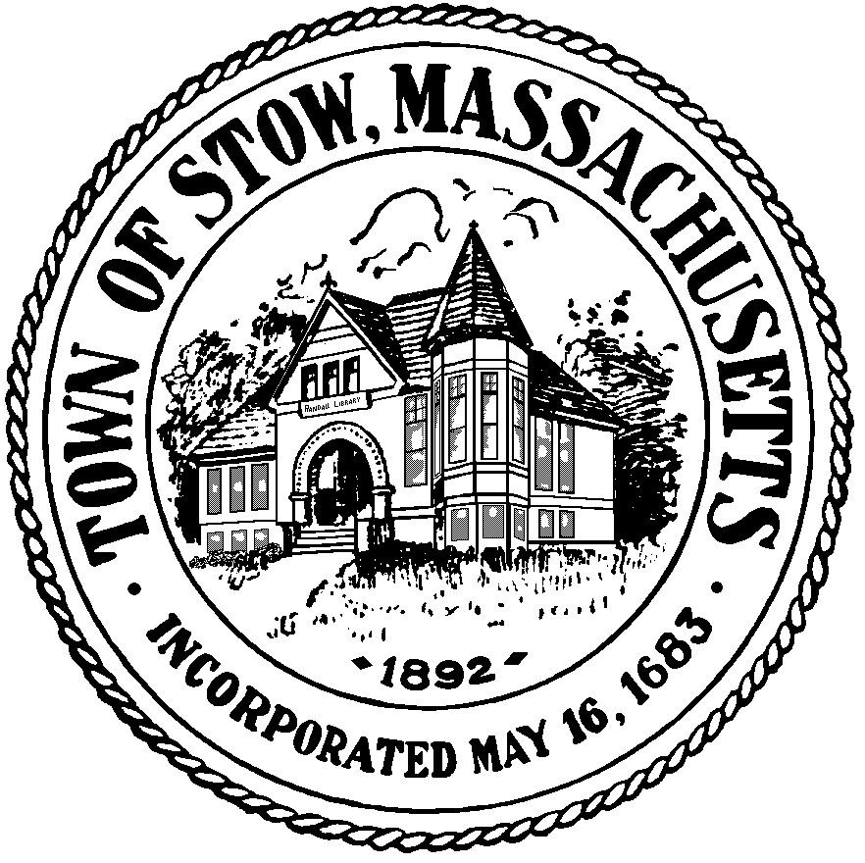

Town of Stow

community preservation committee

Agenda for Monday, June 20, 2011 7:30pm, Town Building
- BILLS & MINUTES
- Discussion with HISTORICAL COMMISSION MEMBERS (re: goals for projects)
- STOW COMMUNITY PRESERVATION PLAN Discussion
- YEAR END BUDGET CLEAN-UP
- POTENTIAL NEW PROJECTS
- NEWS & VIEWS

