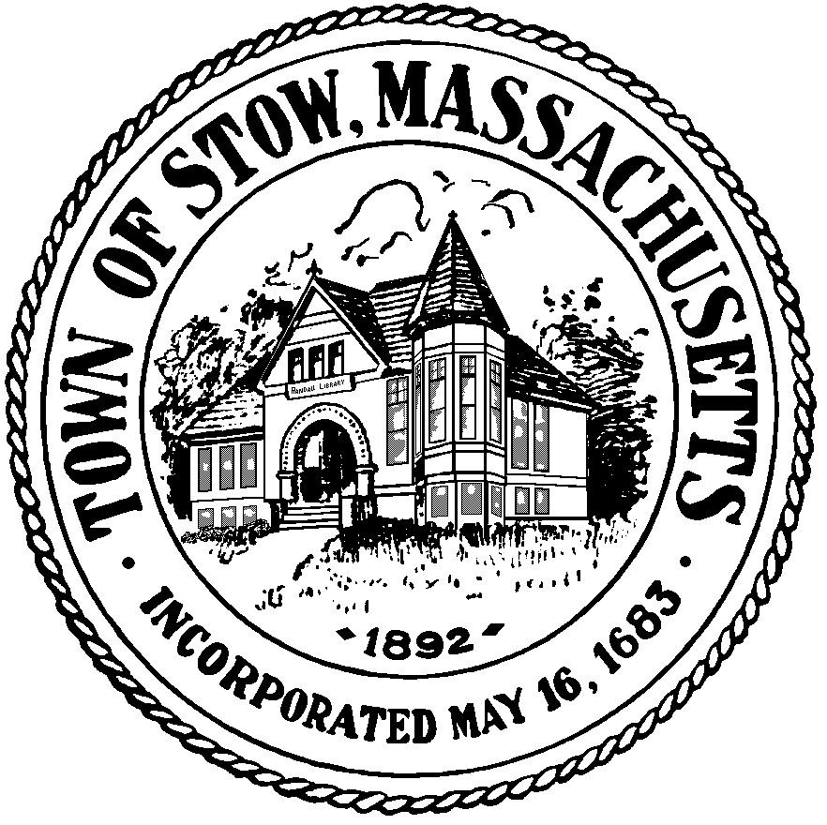

Town of Stow

community preservation committee

Agenda for Thursday, September 1 7:30pm, Town Building
Members from the CPC will attend the Historical Commission meeting and may discuss any CPA related topics on their agenda: including but not limited to the Randall Library and Stone Apple Barn.

Historical Commission's agenda includes: Randall Library Trustees, Larson Apple Barn, Larsen Apple Barn Memorial, West School, Musket Update, CPC Liaison Report, Building Permits, Old and New Business, Treasurers Report, Minutes, and Correspondence.

