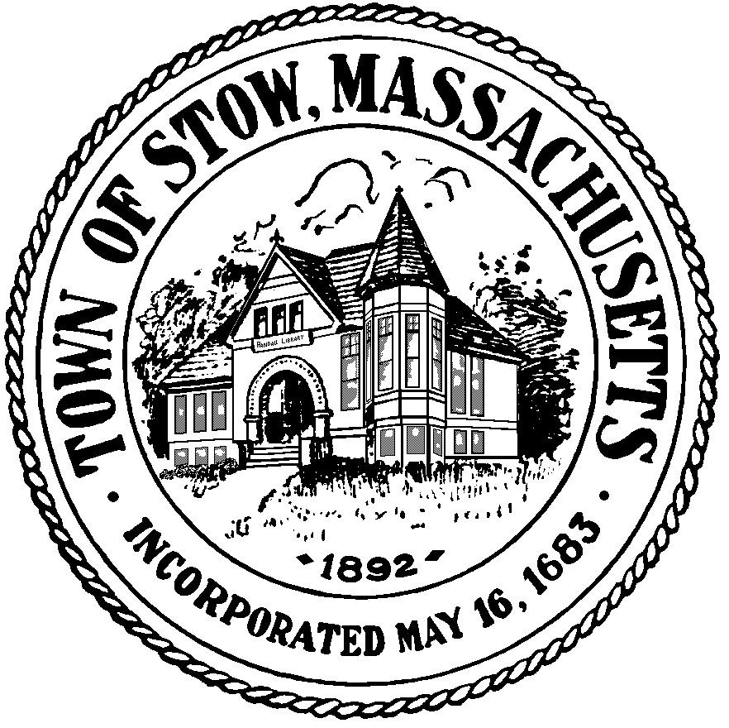

Town of Stow

community preservation committee

Agenda for Monday, January 24, 2011 7:30pm, Town Building
- BILLS & MINUTES
- UPDATE ON CURRENT PROJECTS
- POTENTIAL NEW PROJECTS
- NEWS & VIEWS

