Ceremonial Thanksgiving Meeting
Board of Selectmen
Town of Plymouth

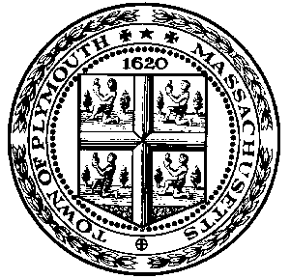

1749 Courthouse, 4 Town Square
6:00 p.m. – 7:00 p.m.
Tuesday, November 22, 2005

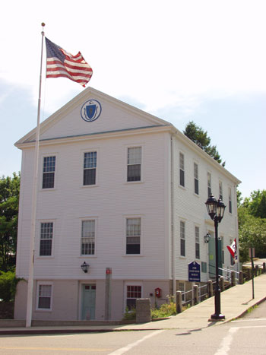

1749 Court House and Museum

The 1749 Court House is a museum right in the center of Plymouth that is free and filled with interesting items from Plymouth's history. It is the oldest wooden Court House and the longest used municipal building in America. The 1749 Court House was originally built for the joint use of the county and the town of Plymouth. The town used it during those periods the circuit court was not in session. When the new courthouse was built in 1820, the town purchased this building for the sum of $2,000 and from that time until the early 1950's, virtually every town department has had its office there. The building was restored and opened to the public as a museum in 1970. The museum houses a fire engine from 1828, the town hearse, items from Parting Ways settlement, display of gifts from Plymouth's sister city Shichigahama, and panels featuring the recent local history book Beyond Plymouth Rock. It is listed in the National Register of Historic Places. The 1749 Court House is steps away from historic Burial Hill, The First Church, Brewster Gardens, and Leyden Street.

~Program of Events~

Procession………………………………………led byKathryn Johnson and Kelly Young of Girl Scout Troop 230

and John Feeney of Boy Scout Troop 47

Call to Order……………………………………………………………………………...Kenneth A. Tavares

“Pledge of Allegiance”……………………………………………………………………………..All Present

Opening Prayer……………………………………………………………………….Reverend Gary L. Marks

National Anthem………………………………………….Members of the Plymouth High Schools Concert Choir

Governor’s Proclamation…………………………………………………………………....David F. Malaguti

Congressional Proclamation……………………………………………………………………Mark D. Sylvia

The Meaning of Thanksgiving……………… ………………….Lucas Babini, Camden Bauer, Samantha Hakkila,

Shaelyn Helminiak, Brendan McGuire, Molly McKenna,

Dylan Mulvey-Welch, Olyvia O'Brien, Nicholas Santos,

Gabrielle Sears,Savannah Sylva,Meagan Walton

Thanksgiving Gift Exchange with Plymouth England………………………………………..Kenneth A. Tavares

Two Voices of Thanksgiving poetry…………………………………………. …...Jordan Holt and Maxx Luddy

Lighting of the Candle………………………………………………………………………………Selectmen

Closing Prayer……………………………………………………………………... Rabbi Lawrence Silverman

