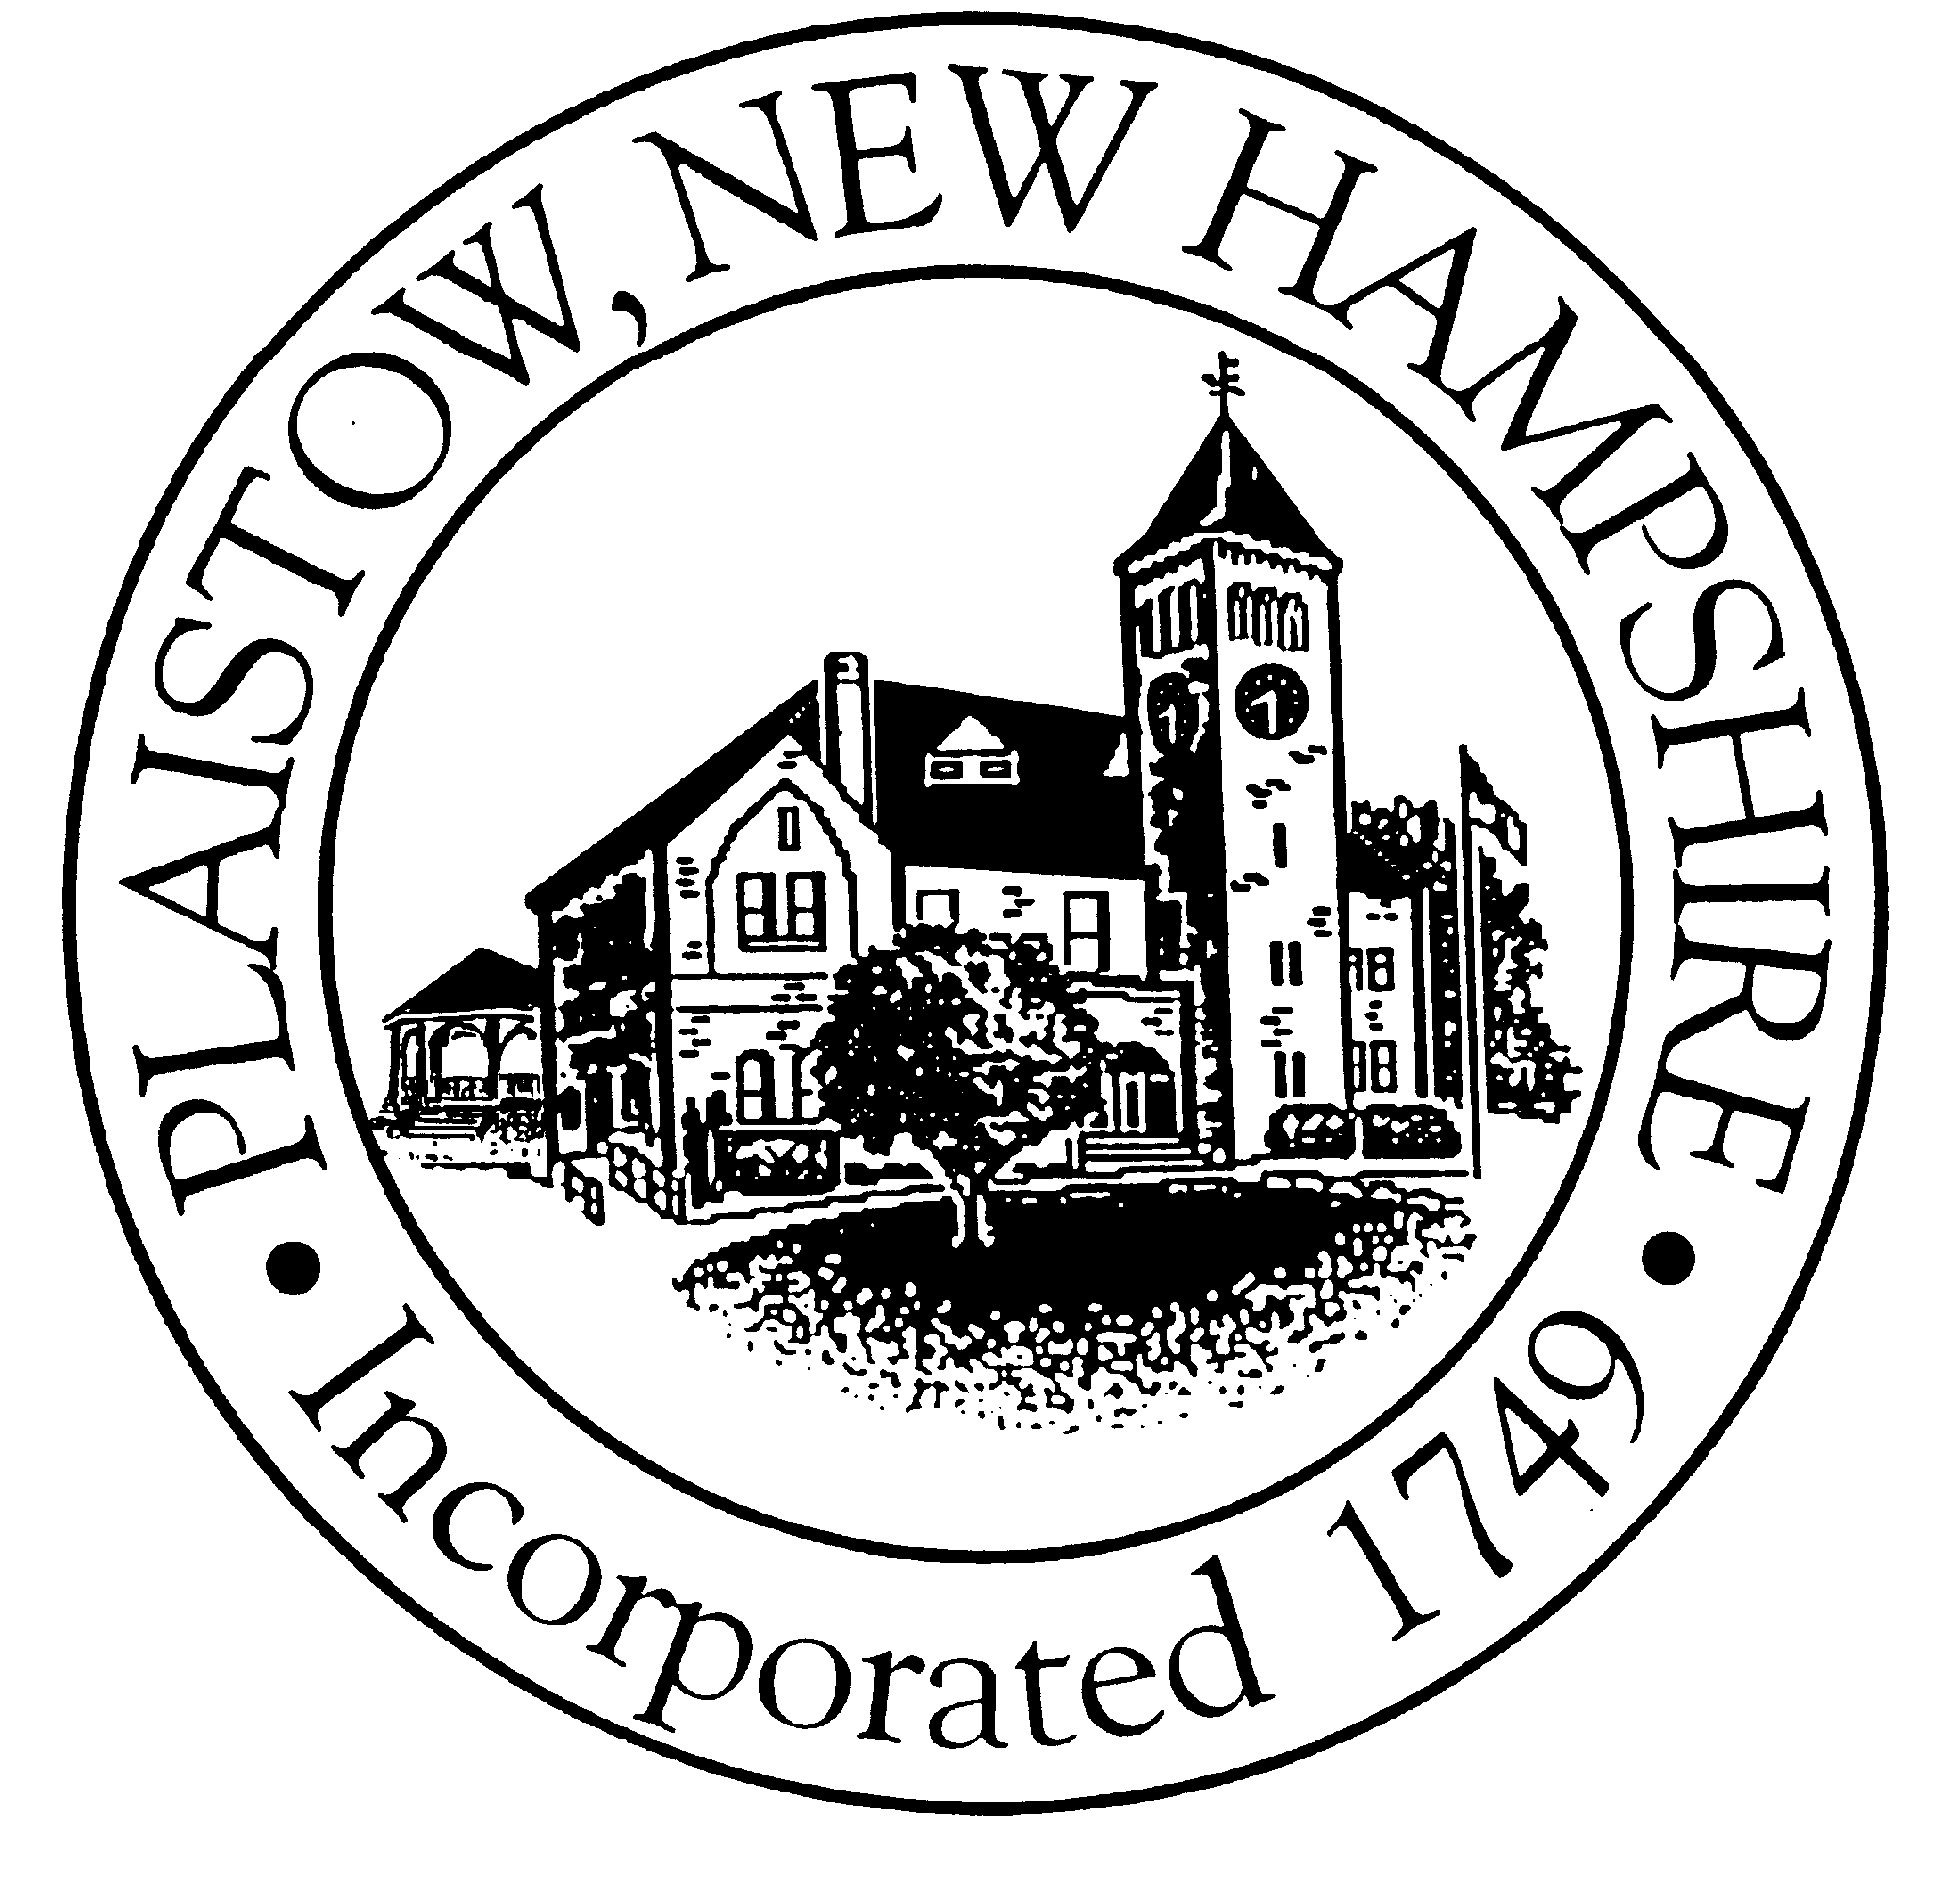
Plaistow First Committee
145 Main Street, Plaistow, New Hampshire 03865
Tel: 603-382-7371, Ext. 14 Fax: 603-382-7183

MINUTES

PLAISTOW FIRST COMMITTEE MEETING
November 9, 2011

The Meeting was Called to Order at 3:36 p.m. by Bob Harb.

ROLL CALL

Committee Members Present: Bob Harb, John Sherman, Dave Hansbury, Bob Gray, Dan Johnson, and Tim Moore.

Absent: Paul Sickel, Charlie Lanza, Dick Latham and George Melvin.

Present for Staff: Leigh Komornick and Mike Dorman.

PLEDGE OF ALLEGIANCE

All stood and made a Pledge of Allegiance to the flag.

MINUTES OF THE OCTOBER 12, 2011 PLAISTOW FIRST COMMITTEE MEETING:

Tim Moore motioned, Dave Hansbury seconded, to approve the minutes of the 10/12/11 Plaistow First Committee meeting as written.

So Voted.

MINUTES OF THE OCTOBER 26, 2011 PLAISTOW FIRST COMMITTEE MEETING:

Dave Hansbury motioned, John Sherman seconded, to approve the minutes of the 10/26/11 Plaistow First Committee meeting as written.

So Voted. (Tim Moore Abstained).

ADDITION OF PROPERTIES OF INTEREST TO THE LIST OF RECOMMENDATIONS:

It was noted that Leigh had modified the list of recommendations based upon the Committee members prior discussion regarding differentiating between “Properties Recommended for Acquisition” versus “Properties of Interest.” Having separate lists would distinguish between those properties that may want to be, upon further review and investigation, recommended for acquisition versus those properties that are more certainly to be acquired.

It was noted that Leigh had modified the spreadsheet to add a new category of “Properties of Interest” (in addition to “Properties Recommended for Acquisition”).

PROPERTIES RECOMMENDED TO SELL:

Tim Moore noted that one factor regarding prioritization of properties to sell is whether they have clear title. If they all have clear titles, than they could have the same priority. Then let Selectmen choose which properties to pursue.

PROPERTIES RECOMMENDED TO ACQUIRE:

Committee members discussed the need to add properties recommended to acquire currently listed under the "Time Sensitive" category to the “Properties Recommended for Acquisition.” This includes the addition of Recommendations Numbers 11, 12 and 21.

It was recommended that the Railroad Depot be added to the list of "Properties of Interest" bringing the total number to 3.

FORMATION OF A SUBCOMMITTEE TO REVIEW THE MAIN STREET STUDY AND PLAN NH RECOMMENDATIONS:

John Sherman noted that a subcommittee should be formed to review the recommendations contained in the Main Street Study and the Plan NH recommendations that will be coming out shortly. It was agreed that once the Town received the Plan NH results, several more public informational meetings should be held on the plan in order to seek further input.

So Voted.

PROPERTIES ADJACENT TO THE TOWN FOREST:

John Sherman and Tim Moore agreed to be on a Subcommittee to review the properties that are adjacent to the Town Forest.

OTHER PROPERTY LISTS:

The Committee agreed on obtaining properties adjacent to the following public facilities:

1) Safety Complex
2) Cemetery
3) Town Hall
4) PARC
5) Penn Box Site (Smith Farm)
6) Smith Recreation Field off Ingalls Terrace
7) Highway Garage
8) Hale Spring Property
9) Historical Society
10) North Main Street/Mount Misery Area
11) Library
12) Courthouse

NEXT MEETING

It was noted that the Plaistow First Committee would meet again on Wednesday, December 14, 2011 at 3:30 p.m..

ADJOURNMENT

Bob Gray motioned, Dave Hansbury seconded, to adjourn the meeting at 4:50 p.m.

So Voted.

Respectfully Submitted,

Leigh G. Komornick, Town Planner
Plaistow First Committee
Recording Secretary
------------------------------------------------------------------------------------------------------------------------

As included in every set of minutes for informational purposes, the following is a list of the subcommittees, persons assigned to them, and their purpose:

Needs Subcommittee includes Bob Harb, Bob Gray and George Melvin. Their purpose is to create a needs list of property and buildings after reviewing the Master Plan and interviewing the Board of Selectmen , Town Manager, Town Department Heads, Fire, Police, and any else the Subcommittee deems they wish to interview. This discussion should include water and conservation issues (to be more particular defined by the Selectmen shortly in response to a request from this Committee.

Use (Usage) Subcommittee includes John Sherman, Dan Johnson, Dick Latham and Charlie Lanza. To review how Town property is presently being used and to recommend properties that should be used differently.

Disposition Committee includes Tim Moore, Dave Hansbury and Paul Sickel. Their purpose is to report on suggested properties that should be disposed of /sold by the Town;

Acquisition Subcommittee includes all members of the Plaistow First Committee. The purpose of this subcommittee is to report on properties the Town should consider acquiring and/or a plan for future Town acquisition of properties.

As staff support to all of the subcommittees, Resource Assignments will be carried out by Leigh Komornick, Mike Dorman & Sean Fitzgerald.

