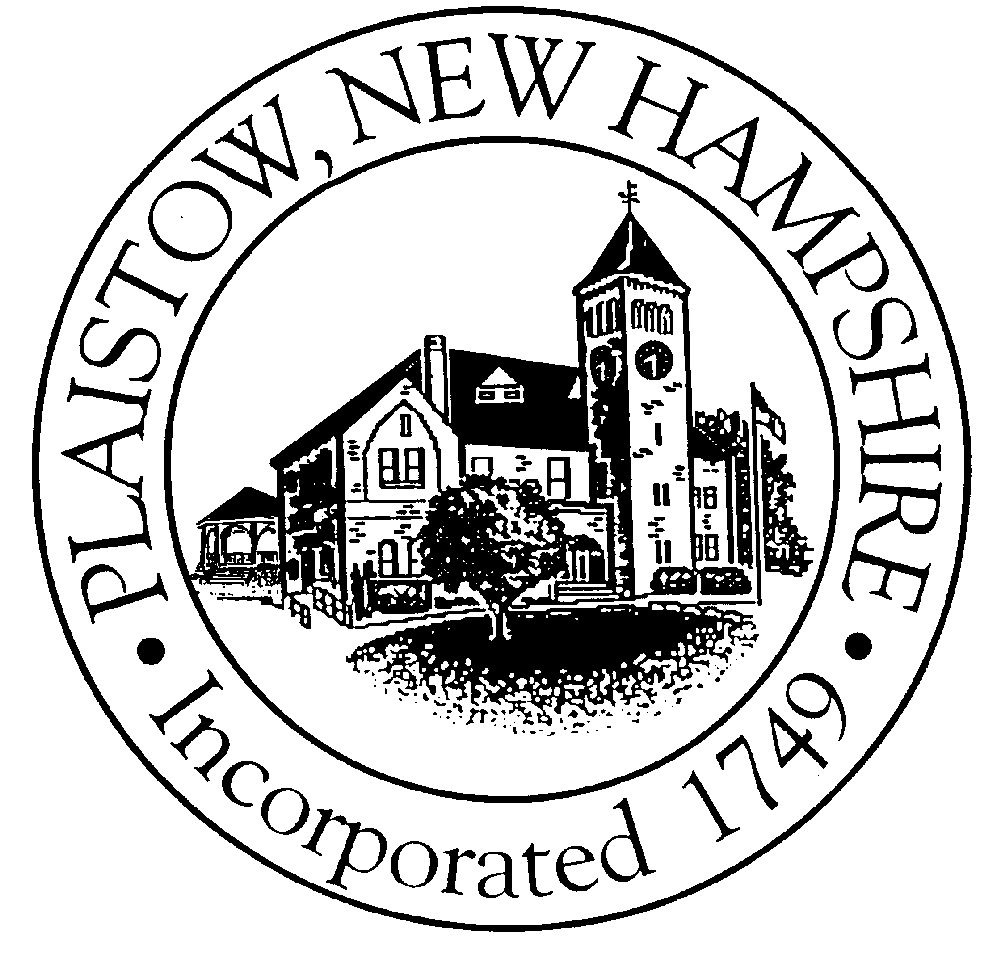

Town of Plaistow  Board of Selectmen

145 Main Street  Plaistow  NH 03865
SELECTMEN MEETING MINUTES

DATE: April 16, 2007

PRESENT: Michelle Curran, Chairman; Lawrence Gil, Vice Chair; Charles L. Blinn, Jr.; Daniel Poliquin; John Sherman; Jason Hoch, Town Manager

CALL TO ORDER: 7:07pm

MINUTES:

PUBLIC COMMENT:
No members of the public wishing to speak.

CABLE:
M. Curran states that last week there was a discussion of replaying minutes. She would like to resume the conversation and take a vote. She states that she would like to see the meetings replayed and the recording would not be the official record.

J. Hoch states that the official record of the meetings would be the minutes.

J. Sherman states that the tapes would be destroyed when the minutes are approved.

C. Blinn states that he thinks it is important to be able to rerun the meetings. This allows residents more chances to view the meeting.

►Motion by L. Gil and second by C. Blinn to authorize the replay of the Selectmen, Planning & Budget meetings for a period of up to the next scheduled meeting.

J. Sherman states that we do not control the cable channel programming, but we can make a recommendation to the Cable Committee.

►Motion changed:
Motion by L. Gil and second by C. Blinn to recommend to the Cable Committee that they include in the programming line up the rebroadcast of the Selectmen, Planning & Budget meetings for a period of up to the next scheduled meeting, after the next meeting the tapes are to be erased.

C. Blinn states that this will be a positive in many ways. He thinks it will be good to get a different perspective of the meeting by watching himself.

VOTE: 5-0-0

MINUTES:
►Motion by L. Gil and second by D. Poliquin to approve the minutes of 4-9-2007, as amended.
VOTE: 4-1-0 M. Curran abstains

HAYNES BOULEVARD:
M. Curran asks the Board if they would like to discuss the warrant article concerning Haynes Boulevard.

J. Sherman believes the Warrant Article wording does not require that we make a decision unless someone comes to us.

J. Hoch states he believes the intent was to allow the Board choice. They could discuss it or wait for someone to bring it up.

C. Blinn states that he discussed this during the Deliberative Session and he believes we need to speak with the Planning Board regarding how this will impact State Line Plaza.

M. Curran states that we can wait unless someone brings this to the Board.

AGENDA:
M. Curran states that she received a call from a resident regarding agenda’s being posted on cable and the website.

J. Hoch states this can be done.

DONATIONS:
M. Curran suggests that the Selectmen discuss the request for a donation made by the Destination Imagination Team.

C. Blinn states that his concern is what makes this group any different from other groups coming in and requesting funds. He is concerned if this will be a one time event or if this is precedent setting.

M. Curran states that the Town Manager will be presenting options at the next meeting.

J. Sherman states that this week is the School Board Meeting and we wanted to see how they would be able to help the students.

LIONS CLUB:
M. Curran announces the Lion’s Club Bird House Auction on May 5th, 10:00AM at the Vic Geary Center.

TOWN MANAGER’S REPORT:
Water Line:
J. Hoch states that last week there were questions regarding the NHDOT preconstruction. He states that Chief McArdle informed him that we have not installed asbestos cement pipe since the original system was installed because the pipe becomes brittle and friable over time. The thrust blocks may not be specifically indicated on the plan, but they are indicated in the specification. Depending on the contractor, they can be prefabricated and dropped in place or they can be poured in place.

►Motion by D. Poliquin and second by L. Gil to authorize the Town Manager to sign NHDOT contract 13803.
VOTE: 5-0 U/A

Area Selectmen Meeting:
J. Hoch states that the Regional Selectmen meeting was rescheduled to May 9th, due to lack of attendance.

Senator Sununu:
J. Hoch informs the public that a representative from Senator Sununu’s Office will be at the Great Hall on Thursday, April 19th.

LEGISLATION:
Representative Norm Major, Representative Ken Weyler, Representative Joe Guthrie and State Senator Michael Downing are present.

N. Major states he reviewed the list of bills of interest the Selectmen highlighted and 20 have been killed, 5 are in referral and 4 have been tabled. He states that he would like to discuss 12 of the bills.

HB456 Limit Health Officer Liability:
N. Major states a hearing is scheduled for tomorrow and he would think the Board was in favor of this.

HB483 Mosquito Control:
N. Major states that this is scheduled for action coming on Wednesday.

K. Weyler states there is money that is earmarked for this.

J. Hoch states that once a Health Emergency is declared we are eligible for partial reimbursement. With the amount of money available it helps us in the beginning of the season but does not in the middle.

J. Sherman states that the amount designated does not seem enough to cover the state.

N. Major states that not all the towns are involved in the program.

L. Gil asks if this is a southern tier program.

N. Major will look into the statistics.

J. Sherman states that each Town is going to need to plan for their programs.

K. Weyler states that if this became a pandemic then the State would step in but this is something Towns should plan for these type of events.

J. Sherman asks who would declare an emergency.

K. Weyler states that the Public Health Commissioner could do this.

Senator Downing states that SB102 addresses giving the power to the Governor to declare this.

K. Weyler states that the House has added money for an outbreak of avian flue medications. This would allow us to purchase the medication to treat the first responders.

HB513 Affordable Housing Commission:
N. Major states this has been assigned to the Senate but does not have a committee.

M. Curran states that she would like the State to be able to assist Plaistow with the Elderly Housing that is being proposed.

J. Sherman states that this is about affordable housing and not elderly housing.

N. Major states that this is for the work force. Our young people are leaving the State because they need more affordable housing.

HB692 Exempt New Industry from Tax:
N. Major states if you meet certain conditions industries will receive tax breaks for a certain number of years. If you do this someone else needs to pick up the taxes.

J. Sherman asks what the qualifications are.

J. Guthrie states that one qualification is that it needs local authorization. This bill is designed to help the northern part of the State.

J. Sherman asks if this passes who will be affected.

K. Weyler states it would affect counties, local and school taxes.

L. Gil states that as we are wresting with school and property taxes it seems counter-effective to take something away from us.

Consensus of the Board is that they are not in favor

HB882 Eliminate Limits on Governmental Suits:
N. Major states this bill raises the amount a community or governmental agency can be sued for. This has not been assigned to a Senate Committee.

J. Sherman states the legislative bulletin he received states that the cap would be eliminated.

N. Major states that this has been amended since the bulletin was distributed.

J. Hoch states that there is a second part about removing immunity from liability.

N. Major asks that J. Hoch email him that portion of the bulletin so he can look into this.

HB907 Restricts Mercury Disposal:
N. Major states that this bill has passed the House and is in the Senate.

J. Sherman states that he is concerned with pollution and he is in support of this bill.

K. Weyler stated that enforcement is an issue.

M. Downing will follow this through the Senate.

J. Sherman asks what they can do to support this.

M. Downing states that writing a letter would help.

►Motion by J. Sherman and second by L. Gil to direct the town Manager to write a letter to Senator Downing regarding HB907.
VOTE: 5-0 U/A

SB58 Budget Vote Appearing:
M. Curran states that this is the first year that we posted the breakdown of votes in the warrant.

K. Weyler states that this is something that Plaistow is obviously already doing.

SB75 NH Rail Transit Authority:
N. Major states that this bill has not been assigned a committee.

J. Sherman asks about rail service in Plaistow.

M. Downing states that this bill could be a vehicle for getting your foot in the door and expressing your concerns. He states that the current plan would mean construction of rail and Massachusetts would have to bring their end up.

L. Gil states it would make more sense to place this where you already have the line.

N. Major states that the first part of the bill does address how this could affect Plaistow.

M. Downing spoke to the president of Gilford Rail and he would be willing to put the rail in if the State would fund it.

J. Hoch asks why a by-bass rail is needed for the stops.

M. Downing states their primary business is freight and not passenger. He states that the spurs are not often enough on the line.

L. Gil asks why they cannot use the spur at Chart Industries.

M. Downing states that he is not an expert on this and these would be questions for the Transit Authority

J. Sherman states that a positive is that the Transit Authority would have significant local representation.

SB206 Investment Authority:
M. Downing states that this allows the municipalities to invest in other bonds and get a bigger return. He states most of the other States are already doing this.

Consensus of the Board is to support this.

SB215 HIV Prevention/Aids Services:
K. Weyler states that a million dollars would be added because of the funding lapse.

Damages & Civil Actions:
N. Major gives the example of this bill allowing suits against a driver and the maker of the car. If the driver settles the maker is the sole party in the judgment.

K. Weyler states that this came out of Judiciary with 15 lawyers supporting it. He feels this was a conflict of interest.

Other:
N. Major states that he has the 2007 numbers for education grants. He gives J. Hoch the document for the Governor’s Plan.

Senator Downing & K. Weyler states they have not seen the numbers.

M. Downing states that the House placed the education funding into the budget and he is not sure why.

K. Weyler explains the design of the education trust fund and the amounts that would be needed. Because of the way it was written you could not use the surplus for anything else. If we eliminate the trust fund we could then use the surplus and place all of the funds into the general fund. We can still use the money for education and then use the rest for other programs.

M. Downing states that we start with the ways and means committee tomorrow. We have not started this project yet, the budget came from the House and then we begin to look at revenues. We just passed the Governor’s Constitutional Amendment and M. Downing was against this. They have not defined what an adequate education is and then how do you fund something you can not define. He does not see the rush in this and is afraid of unseen complications. He is concerned with the amount of bills on litigation and he is concerned with where the money will come from. If you have any questions call and write to him.

K. Weyler states he has always been proud of the budgets produced. It was never that far off, max 3 or 4%. He was disappointed in this year’s process. They did not look at things line by line and they were not allowed to look at ways and means. He could not support the budget because of this. He refers to the one other time this happened in 1998 and it resulted in cuts, hiring freezes and postponed contracts. He sees this happening again for the next 2 years. He will continue to work at budgets and spending and he will continue to do his best. He states that the Fish & Game is having issues. He states that the allocation of funds needs to be looked at to increase productivity. He would like to look at the vehicle use and see reductions. He is concerned with vehicles being used for commuting and not State activity.

J. Guthrie states that most of his committee is very conservative. His experience is as a Selectman and with local government. His committee is always looking whether an abatement or exemption is going to impact the tax payer. With every exemption someone is going to have to cover the costs. He wants to have a positive impact on the local levels.

N. Major states that he is on the Ways and Means Committee and they are usually working on revenues at the beginning of the year. This year they were not allowed to do this until after the Governor presented the budget. After he presented the budget, the committee was busy working on bills. Then they had to rush on revenues. The Finance Committee came and stated this is a lean budget and they were asked to raise the revenues as high as possible. He states that he was not allowed to explain why we could not work this way. He put in an amendment on the floor and it failed on party lines. He was asked by the Speaker of the House to be on a Sales Tax Committee. He states he is going to continue to work at keeping NH sales tax free.

M. Curran thanks all the guests for their service and especially thanks N. Major for his involvement in Plaistow. She asks what the Representative and Senator would like to see improved.

J. Guthrie states he would like to see fewer party lines drawn. He found that the committees really work together and parties listen to each other. It works well because people bring a lot of backgrounds to the committees and this allows for good discussions and decisions made. When things get to the floor it often changes and party lines are drawn.

N. Major states that things need to be more consensus driven. He states that this has worked well in the past and he would like to see a move towards consensus in the future.

K. Weyler states that there is a conflict of visions. He believes there are independent people but then there are those that want to be cared for and refers to them as the “nanny population.”

J. Sherman states that the voters of NH are quite independent and as a result you see a lot of people registering as Independents. He states that K. Weyler introduced HB479 Default Budget and asks for clarification on what it is about.

K. Weyler states that you cannot take a one time expense and roll it into the default budget. He uses the example of a slate roof being a one time budget item and not needing to be rolled over into the default. He would like to see default budgets be more accurate. He believes that proper default budgeting can be accomplished on the local level.

J. Guthrie states that people involved in the budget procedures are familiar with this.

J. Sherman asks about HB669 Kindergarten Aid.

K. Weyler states that this bill was an incentive to adopt Kindergarten. The construction Aid money is 75% or 55%. This bill was not written clearly and there was little money from the original appropriation. They let it expire and took each case like Timberlane and made sure that they will get their money.

L. Gil asks how often the Legislators get invited to the other Selectmen meetings.

The consensus of the guests is that it is not often and the School Districts tend to invite them more.

NONPUBLIC:
►Motion by J. Sherman and second by D. Poliquin to enter into nonpublic session pursuant to RSA 91-A: III-d Property Acquisition.
ROLL: J. Sherman-yes, M. Curran-yes, C. Blinn-yes, D. Poliquin-yes, L. Gil-yes

►Motion by J. Sherman and second by D. Poliquin to exit nonpublic session and seal the minutes for 90 days.
ROLL: J. Sherman-yes, C. Binn, M. Curran-yes, D. Poliquin-yes, L. Gil-yes

ADJOURNMENT:
Meeting adjourned at 9:29pm.

Respectfully submitted,
Nicole Carr
Recording Secretary

