Economic Development Commission
40 Main Street – North Stonington, CT 06359
Phone-860-535-2877x31 – 860-535-4554-Fax
edc@northstoningtonct.gov - nsedc@icloud.com

EDC MEETING MINUTES
March 20, 2014
NEW TOWN HALL CONFERENCE ROOM
DRAFT

Meeting Convened at 6:35 PM

Members Present:
Chair, Brett Mastroianni
Vice-Chair, David Isom
Treasurer: Christine Wagner
Secretary: Marilyn Mackay
Andrea Sadowski
Raymond Geer

Members Absent:
Robert Kimball
Bernard "Bing" Bartick

Town Officials, Guests & Members of the Public Present:
Juliet Leeming, SPZEO
Robert Mills, NCDC
Jason Vincent, NCDC

Approval of Minutes:
January 16, 2014 Minutes: Moved for approval by Christine; seconded by Brett, approved unanimously.
February 20, 2014 Minutes: Moved for approval by Christine; seconded by David, approved unanimously.

Treasurer's Report:
Treasurer reported a balance in the account of $3,309 after having paid three checks this past month.

Christine moved; David seconded, and it was unanimously approved to reimburse Juliet Leeming for $150 in travel expenses she spent for the ICSE conference.

At Juliet's request, Ray moved; Chris seconded to support a change in the OR zone from 20,000 to 30,000 square ft. to accommodate an Italian food company to move forward in purchasing Randall's Ordinary.

It was announced EDC would go before the Board of Finance on Wednesday, April 2, 2014, for budget approval. Due to this budget's importance to EDC's future, it is recommended we all attend.

A reminder of SECTER's Webinar on Pop-Up Businesses will take place on Wednesday, March 26, 2014.

Alternates:
George Tattersall and Barbara Campagna were nominated as Alternates on EDC. Marilyn moved the motion; David seconded, and they were passed unanimously. Their nomination will now go before the Board of Selectment for final approval on Tuesday, March 25, 2014.

David moved for adjournment; Andrea seconded at 8:15 PM.

Next meeting: Thursday, March 20, 2014, 6 PM.

Respectfully Submitted,
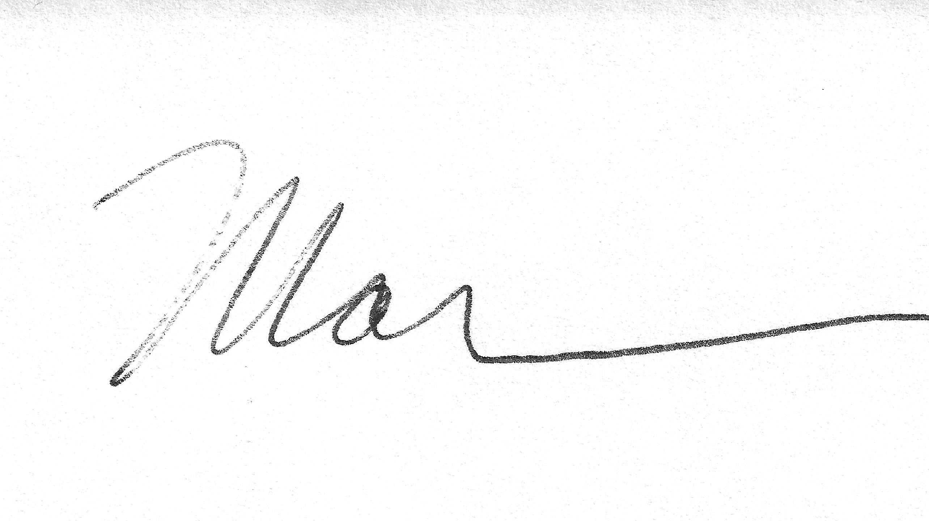
Marilyn Mackay, Secretary

