Economic Development Commission
40 Main Street – North Stonington, CT 06359
Phone-860-535-2877x31 – 860-535-4554-Fax
edc@northstoningtonct.gov - nsedc@icloud.com

EDC MEETING MINUTES
February 20, 2014
NEW TOWN HALL CONFERENCE ROOM

Meeting Convened at 6:05 PM

Members Present:
Chair, Brett Mastroianni
Vice-Chair, David Isom
Secretary: Marilyn Mackay
Robert Kimball
Andrea Sadowski
Bernard "Bing" Bartick
Raymond Geer

Members Absent:
Treasurer, Christine Wagner

Town Officials, Guests & Members of the Public Present:
Juliet Leeming, SPZEO
Barbara Campagna
Brent Woodward
Anna Isaacs, The Day

Approval of Minutes:
January 16, 2014 Minutes were held for approval until the next meeting for Christine Wagner's missing notes due to Secretary's late arrival.

Bing Bartick made a motion to approve the minutes of the January 30, 2014 Special Meeting; seconded by Bob Kimball. Passed unanimously.

Additions to the Agenda:
Motion made by Ray Geer; seconded by Andrea Sadowski to add “Public Comment” to the agenda. Passed unanimously.

Motion made by Bob Kimball; seconded by Ray Geer, to add discussion of the Proposed Budget to the Agenda. Passed unanimously.

New Business:
Brent Woodward, former Board of Finance member, spoke to the need of updating missing EDC annual reports. Juliet Leeming and Peter Bogoian had apparently written something in 2012 but it was never submitted. Juliet stated she had drafted an Annual Report for FY2012-2013 and had asked we review and approve it. Bob Kimball made a motion to submit that report as our Annual Report for FY 2012-2013. Ray Geer seconded; unanimously approved.

Four new line items were added to the 2014/15 EDC Budget. The new budget totals $41,051. Bob Kimball made a motion to approve the budget; seconded by David Isom; unanimously approved. Budget will be presented to BOS on 2/25/14

Officer-subcommittee Reports:
No Treasurer's Report. In the absence of the Treasurer, SPZEO reported she submitted two bills for payment: Eastern CT Chamber of Commerce for $75; Raymond Geer (reimbursement for printing) for $42.64.

SPZEO requested a letter of support for the proposed Regulation Change to allow an increase in maximum square footage for a Warehouse in the OR Zone to accommodate an Italian Food Company distribution facility.

Marilyn Mackay discussed the appointment of Alternate EDC members and introduced Barbara Campagna. The names of the two potential candidates - Barbara and George Tattersall will be presented to the BOS on 2/25/14 for consideration.

Juliet Leeming presented her Activity Report that included property inquiries, new applications for commercial use and meetings related to Economic Development. Of particular interest were:
- Randall's Ordinary under contract to an Italian Culinary company. Initially this company will build a warehouse to distribute their product. Long –term plans include restoring the existing buildings to be run as a restaurant/Inn.
- SPZEO met with Robert Mills and Jason Vincent of NCDC and invited them to attend EDC's March Meeting.
- SPZEO met with Michael Blair re: redevelopment possibilities in the C2 Zone involving properties owned by Kosmor LLC (Green Onion). Plans would include adding mixed use and a pedestrian extension to NS Village.
- SPZEO presented draft of FY 2014-15 Annual Report for Review.

SPZEO and subcommittee members updated Commission members on Initiatives 1 & 9. Ray Geer showed the new website and explained the remaining steps required for site completion.

Bing Bartick moved for adjournment; Bob seconded at 8:15 PM.

Next meeting: Thursday, March 20, 2014, 6 PM.

Respectfully Submitted,
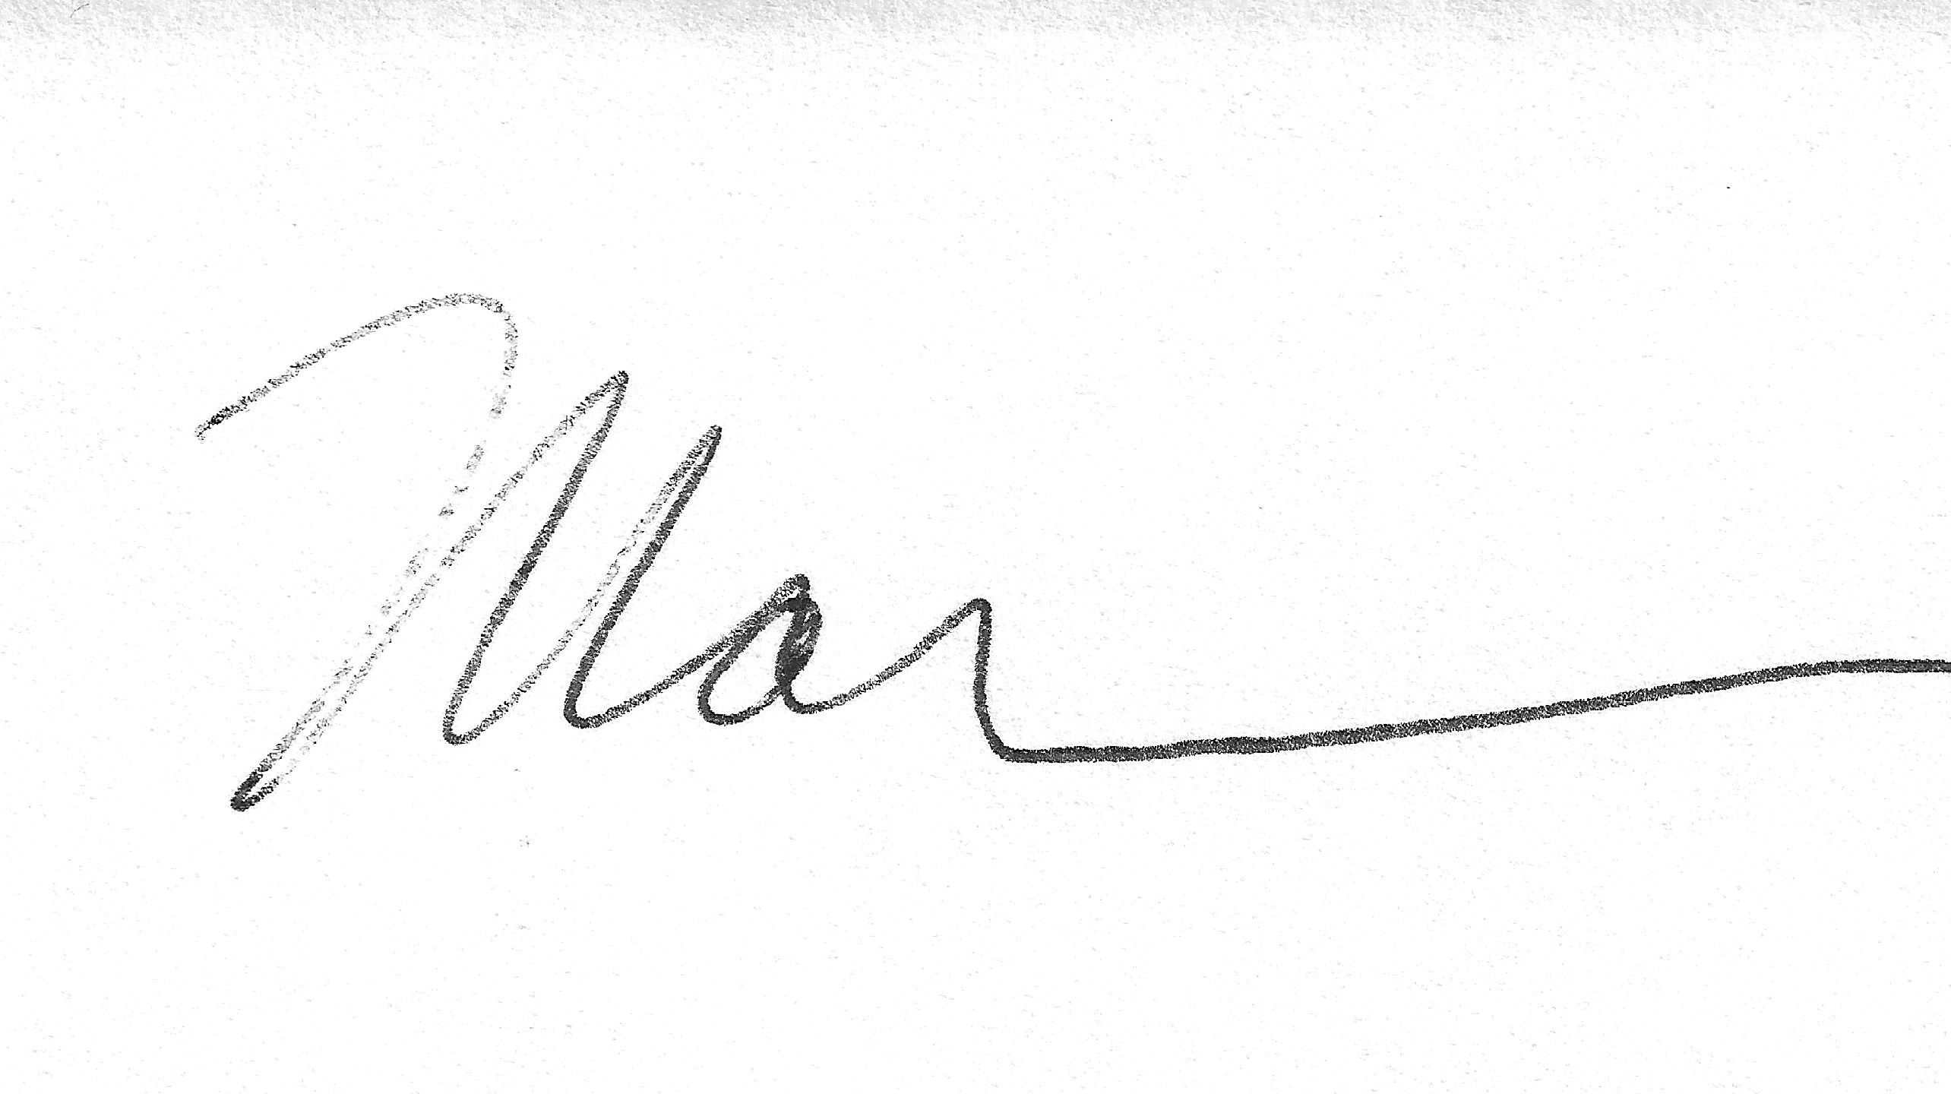
Marilyn Mackay, Secretary

mm

