Economic Development Commission
40 Main Street – North Stonington, CT 06359
Phone-860-535-2877x31 – 860-535-4554-Fax
edc@northstoningtonct.gov - nsedc@icloud.com

EDC MEETING MINUTES
DECEMBER 12, 2013
NEW TOWN HALL CONFERENCE ROOM
DRAFTS

Meeting Convened at 6:07 PM

In attendance:
Chair, Brett Mastrioanni
Treasurer: Christine Wagner
Secretary: Marilyn Mackay
Robert Kimball
Andrea Sadowski
Bernard "Bing" Bartick
Raymond Geer
Juliet Leeming, ZEO

Not attending:
Vice-Chair, David Isom

Approval of December 2013 Minutes passed unanimously

Treasurer's Report: Balance $3,230.

A pragmatic perusal of EDC's Action Plan forced adjustment on timelines for completing the eleven initiatives listed therein.

A meeting is scheduled: 7 PM, January 30, Town Hall, with Boards of Selectmen and Finance, Planning & Zoning Comm., and Affordable Housing Committee members.

It was agreed to invite Deb Donovan, SECTER, back to revisit her previous presentation for new members on the Commission. Juliet pointed out the importance of an EDC representative attend SECTER meetings on the third Thursday of each month, 3 PM.
Ray and Bob have worked with Miriam of Virtual Town Hall to get EDC's website up and running and hope to have a template for the February meeting. Juliet will send fifteen photos to them.

EDC's 2014/15 Budget, prepared by Juliet, was discussed and adjustments were made adding $1,000 to Supplies, Printing, etc., for a total of $1,500; increase Postal Permits & Mailings, if needed; include membership in Eastern CT Chamber of Commerce for $104; round down website cost to $1,200 . The budget was moved by Bob Kimball and seconded by Christine; unanimously passed.

It was agreed to submit the cost of $25-$30,000 for a part-time Economic Development Specialist to the Boards of Selectmen and Finance. Bob moved the question and it was seconded by Marilyn; unanimously passed.

Discussion prevailed to resume EDC member activities to contact existing, and particularly new, North Stonington business owners on a regular basis. Juliet will create a spreadsheet for such visitations and supply monthly Activity Reports.

A new wine bar enterprise is scheduled to open the end of January 2014 on the premises of Gourmet Galley. Brett will contact the owners.

Juliet is working on a "Town Tour" with map for potential business people to learn about NS.

Efforts are being made to find two Alternate Members for EDC okayed by a Town Meeting on October 11, 2013.

A guidance protocol has been established for helping potential businesses needing information to start up in NS. It was agreed that Brett will speak with Dan Spring, Chair of Board of Finance, re staffers interfering with this established sequence.

Meeting adjourned at 8 PM. Next meeting: Thursday, February 20, 2014, 6 PM.

Respectfully Submitted,
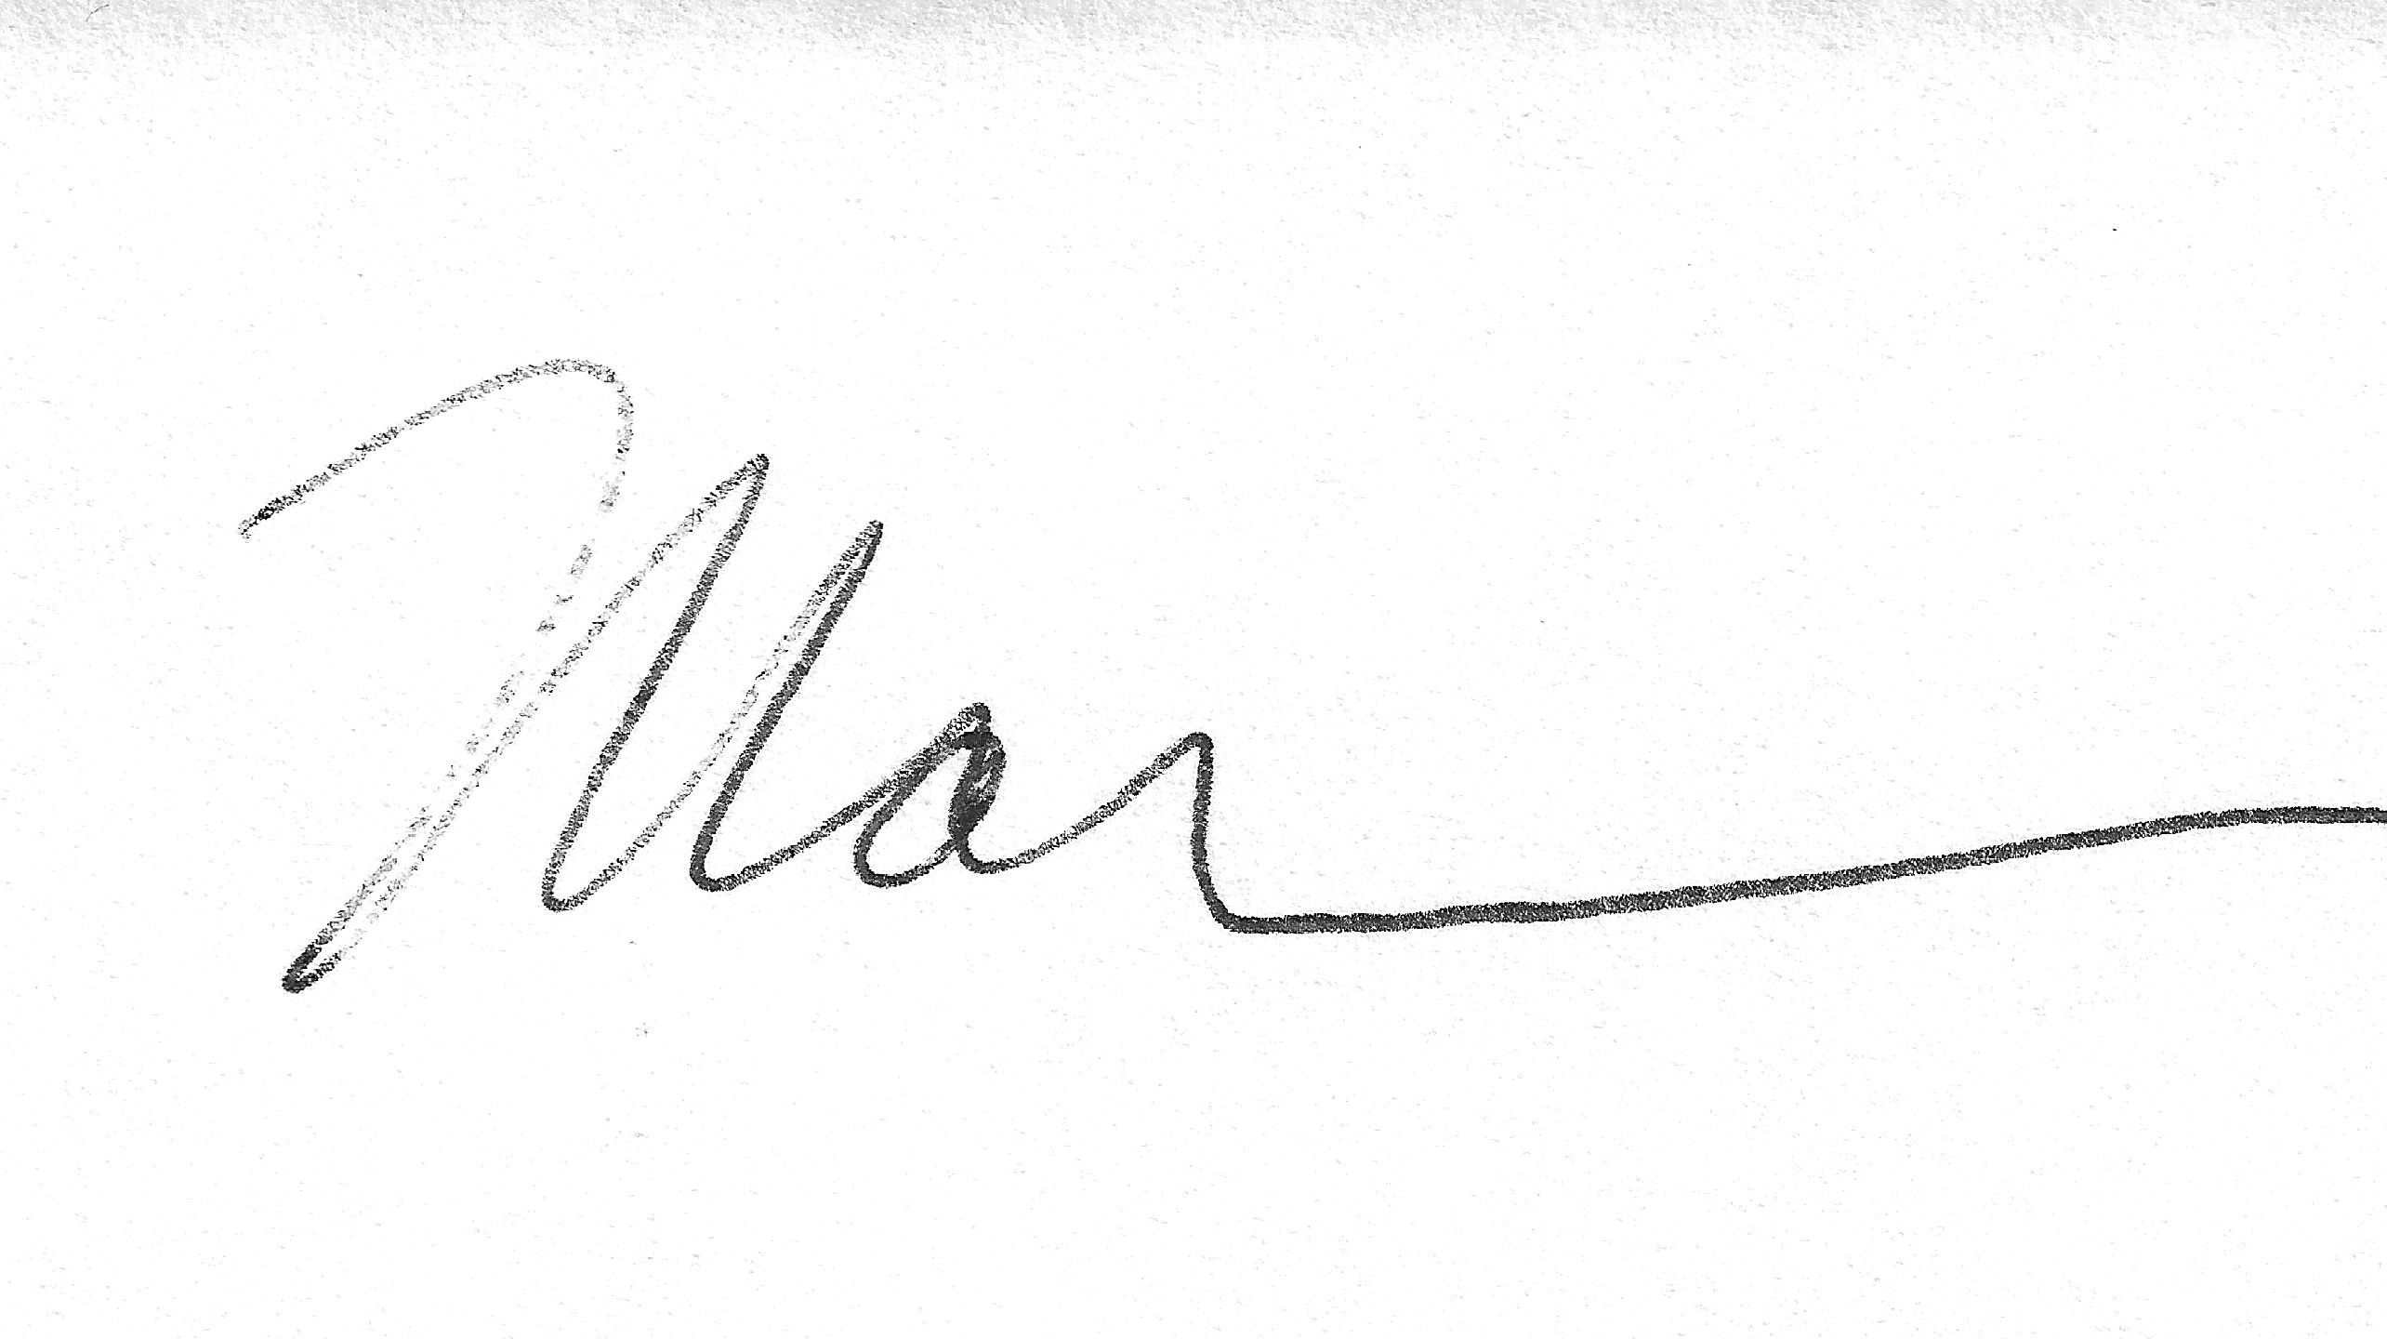
Marilyn Mackay, Secretary

mm

