Economic Development Commission
40 Main Street – North Stonington, CT 06359
Phone-860-535-2877x31 – 860-535-4554-Fax
edc@northstoningtonct.gov - nsedc@icloud.com

EDC MEETING MINUTES
September 19, 2013
NEW TOWN HALL CONFERENCE ROOM

Meeting Convened at 6:05 PM

In attendance:
Chair, David Isom
Treasurer: Christine Wagner
Secretary: Marilyn Mackay
Raymond Geer
Robert Kimball

Absent: Peter Bogoian
Vice-Chair, Brett Mastrioanni

Approval of Minutes: There was no quorum at the August 15, 2013 meeting therefore no minutes were recorded. Minutes of July 18, 2013 were amended changing adjournment time from 8 PM to 7 PM and moved by Ray, seconded by Bob and unanimously approved.

Treasurer was unable to pick up the current report.

Approval was requested for the signing of a contract by Chair David Isom and to have a check cut for $1,295 to the new EDC webmaster, Advanced Municipal Web Services, to create EDC’s site . Chris moved the motion; Bob seconded. Motion passed unanimously.

A Marketing Packet Presentation folder was approved for printing up to the cost of $1,000. Chris moved the motion; Bob seconded. Motion passed unanimously.

It was agreed for David to pursue the hiring of a part-time Town employee, to report to EDC and carry out its responsibilities particularly to follow through on the Team Handbook. David moved the motion; Bob seconded. Motion passed unanimously.

Meeting adjourned 7:05 PM.

Next meeting: Thursday, October 17, 2013, 6 PM.

Respectfully Submitted,
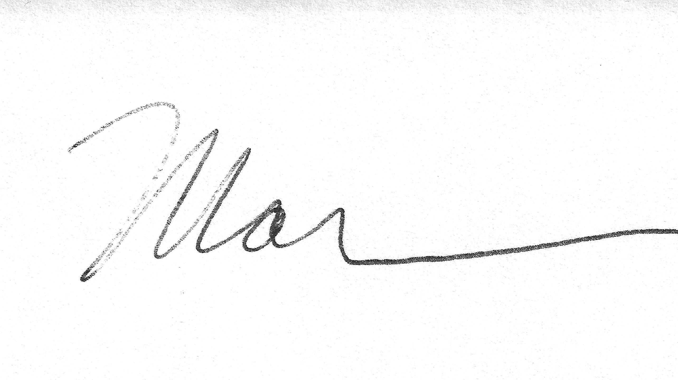
Marilyn Mackay, Secretary

mm

