

**Economic Development Commission**

**40 Main Street – North Stonington, CT 06359**

**Phone-860-535-2877x31 – 860-535-4554-Fax**

[**edc@northstoningtonct.gov**](mailto:edc@northstoningtonct.gov) **-** [**nsedc@icloud.com**](mailto:nsedc@icloud.com)

EDC MEETING MINUTES

November 21, 2013

NEW TOWN HALL CONFERENCE ROOM

Meeting Convened at 6:07 PM

In attendance:

Chair, David Isom

Vice-Chair, Brett Mastrioanni

Treasurer: Christine Wagner

Secretary: Marilyn Mackay

Andrea Sadowski

Bernard "Bing" Bartick

Not attending: Raymond Gee

Guest: Nick Mullane, First Selectman

Approval of Minutes: There was no meeting in October therefore minutes from the September meeting were approved with three ayes and 2 abstentions.

Treasurer was unable to pick up the current bank balance. $3,042 was spent within the past two months.

Christine will visit with First Selectman Nick Mullane to ascertain whether he had mailed a letter to Deb Donovan of SECTER to request financial assistance to fund North Stonington's natural gas line extension to Route 184. We discussed assigning a board member as our SECTER liaison and attend their monthly meetings held on the fourth Thursday of each month.

Nick appeared at the meeting and brought us up-to-date on sewer and gas line status. Christine will pick up data from him on or before December 15, 2013.

It was agreed to pursue an appropriation for a part-time EDC Specialist and to pursue the status of Advanced Municipal Web Services who are developing EDC's website.

The group agreed to recommend to the Republican Town Committee Chair, Sandra Steinhart, she forward Robert Kimball's name to the Board of Selectmen to approve his filling the two year Republican opening on EDC as quickly as possible.

EDC's new members, Andrea and Bing, were introduced and board members attempted to bring them up to date on past activities.

It was agreed to change the December 2013 meeting date from 19th to the 12th due to the Holiday Season. Dates and time for the 2014 scheduled EDC meetings were approved - third Thursday of each month at 6 PM at New Town Hall Conference Room.

Bing moved to adjourn the meeting at 6:57; Christine seconded.

Next meeting: Thursday, December 12, 2013, 6 PM.

Respectfully Submitted,

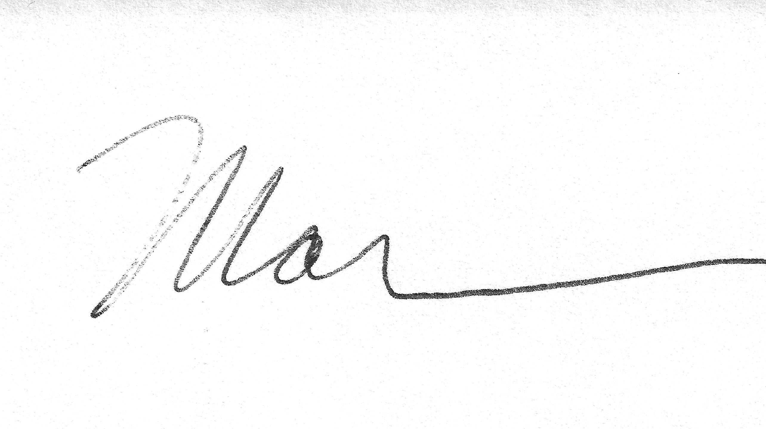

Marilyn Mackay, Secretary

mm