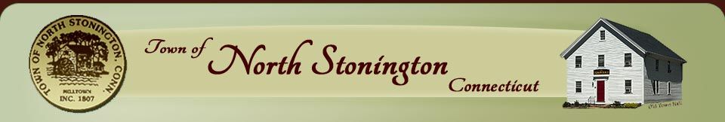
Economic Development Commission
40 Main Street – North Stonington, CT 06359
Phone-860-535-2877x31 – 860-535-4554-Fax
edc@northstoningtonct.gov - nsedc@icloud.com

EDC MEETING
Thursday, November 20, 2014 6 PM
NEW TOWN HALL CONFERENCE ROOM
Workshop
AGENDA

Attendance
• Call to order
• Public Comments

Minutes, Treasurer's Report, Agenda
• Approval of Prior Meeting Minutes
• Treasurer's Report

Executive Session
* Update on EDC Position and review of resumes

Adjourn

