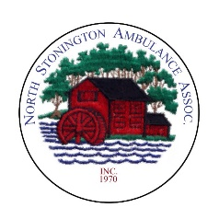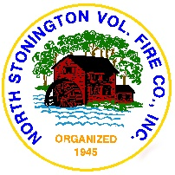

**Center for Emergency Services**

**North Stonington**

*40 Main Street*

North Stonington, Connecticut 06359

*(860) 535-2877*

*Fire.EMS.comm@nsvfc.org*

Agenda

Regular Meeting

**Place:** North Stonington Volunteer Fire Co., Inc.

267 Norwich-Westerly Rd.

North Stonington, CT 06359

**Date:**  August 10, 2015

**Time:** 7:00 PM

**Call to Order**

**Attendance**

**Invoices for Payment:**

Day Pitney invoice #33849486 – Bond Counsel - $5010.62

**Minutes:**

**Correspondence:**

**Via e-mail to Committee**

Notes of August 6 Pay Requisition Meeting

**Discussion**

**Public Comments and Questions**

**Old Business**

Continued discussion on accurate project budget figures

**New Business**

**Adjournment**