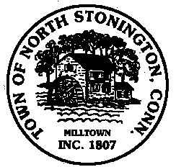 Town of North Stonington
Board of Selectmen Special Meeting
New Town Hall Conference Room
June 21, 2106
7:00 PM

AGENDA

1. Call to Order/ Roll Call
2. Pledge of Allegiance
3. Public Comments and Questions
4. Correspondence
5. Minutes
6. NSAA Run Status Report
7. FY2016-2017 Budget –Referendum Results (June 20, 2016)
a. Discussion and Possible Action on FY 16-17 mill rate-
CGS 12-123
9. Joseph Moran request to takeover Streetlight (Eversource)
invoicing
10. Public Comments and Questions
12. Union Negotiations Update (Executive Session)
13. Adjournment

