- Call to Order
- Public Comments and Questions*
- Board of Selectmen
- 2010/11 Budget/Budget Spreadsheet
  - Approval of BOF 2010/11 Budget
  - Revision A Review
  - BOE Request for Line Item in Capital Non-Recurring Account
- Board of Finance Strategy
- Management Reports/Board of Finance as Audit Committee/GASB 45 OPEB.
- Town Report for June 30, 2009
- Previous Minutes
- Correspondence
- Future Agenda Items Identification
- Adjournment
*Note: The Board of Finance respectfully requests that the public comments not exceed two minutes per person per agenda item. Comments after Item #2 of the agenda may be accepted by a Board of Finance motion. It is the Board of Finance policy that Board of Finance meetings shall try to adjourn not later than 11:30 PM.
Respectfully Submitted,
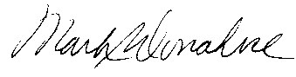
Mark S. Donahue
Chairman, Board of Finance

