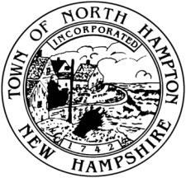

NOTICE OF PUBLIC HEARING

North Hampton Select Board

Notice is hereby given that a public hearing of the **Select Board** will be held on the **27th of May** at **7 pm** at the Town Hall, located at 231 Atlantic Avenue, North Hampton, New Hampshire.

The purpose of the hearing is to consider a proposal given by the Municipal Facilities Committee on the Town Campus.

Posted: Friday, May 15, 2015