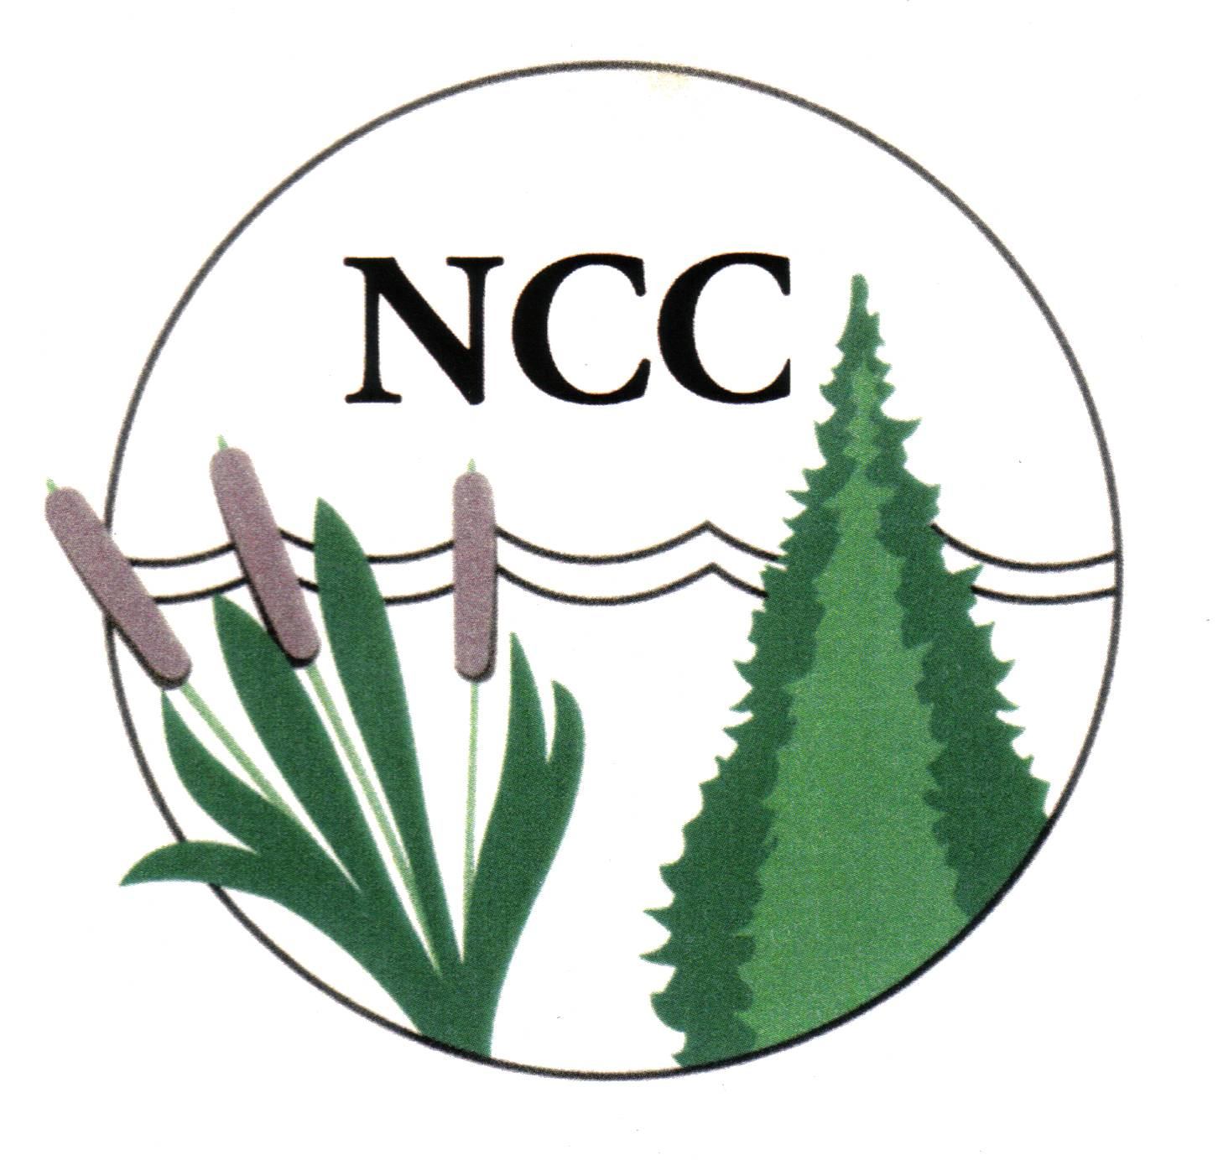

NEWBURY CONSERVATION COMMISSION
Special Meeting Minutes March 14, 2006

Present: William Weiler, Deane Geddes, Frank Perrotta; Elise J. Lawson and John C. Severance.

Old Business:
- Conservation Plan. Interview with Elise J. Lawson and John C. Severance, proprietors of Watershed to Wildlife, Inc., a natural resource consulting company. Meeting convened at 9:30 a.m. with comments by Lawson. WtoW is in its sixth year, having accomplished a diversity of projects for places in New Hampshire like Enfield, Goshen, Plymouth and Berlin. Both proprietors are certified wetlands scientists. The commission was referred to their website www.watershedtowildlife.com for resumes, client contacts and project examples.

The commission reviewed several of WtoW’s projects, including their Ammonoosuc Watershed Region Conservation Plan. The consultants said they would use the 2001 Newbury Natural Resources Inventory as a guide to limit field work, but said field work would have to be done to single out important areas in town. The commission reviewed the NRI the consultants did for Dalton. The consultants said they rely heavily, when producing any study or plan, on public and official town input. They said they usually conduct preliminary public hearings and then a final hearing upon completion.

Weiler noted that Newbury did not contain a lot of valuable wetlands; the town is mostly poorly drained soils. He said the commission hadn’t yet decided what a Newbury conservation plan should contain. He said the Conservation Fund, and possibly other town funds, should be used to protect worthy areas once the conservation plan details specific goals and projects.

Lawson said a conservation plan would include a large-scale stewardship plan and a timeline for an action plan tailored to town goals. Severance said a public meeting could determine if the town favors stricter controls for specific areas. Weiler said public input is good early in the process. He said input he’s had over the years shows the townspeople favor maintaining the town’s rural character. Forested hillsides are most important. Weiler said the town’s skyline ordinance has failed to protect hilltops. Severance said a conservation plan was a great tool, but that doesn’t mean the town would have to back it up in court, if necessary. Weiler said Newbury has approved restrictive regulations to ensure protection. Prime wetlands designation hasn’t been necessary because town regulations are so prohibitive. It’s still important, Weiler said, for the conservation plan to make recommendations on zoning controls. Severance agreed a conservation plan was a great way to cover it.

Regarding preparation of a conservation plan, Severance said that after a review of all available data and consideration of input from the public and town officials, WtoW would identify any special wetlands that need attention, and develop reasons for that protection. He said the conservation plan would include an action plan that would give assignments to projects. Lawson said field work would help WtoW focus on concerns developed from public input. GIS data alone would not provide the detailed information needed to identify sensitive areas such as wildlife corridors and deer yards. Weiler said field evaluation would provide better information that could be used to avoid development. He noted that Newbury contains several important hiking trails that are unprotected.

Lawson said the conservation plan would contain full-size plot maps that would show people attending a hearing where they are in relation to areas of interest. All data developed would belong to the town. Weiler noted that the Upper Valley Lake Sunapee Regional Commission may help with mapping, at no or low cost since Newbury is a member. Severance said WtoW’s computer files would be usable by UVLS.

Weiler noted that Warner had done a resources inventory for its Mink Hills area, including a map that assigned a priority, by tax lots, to areas that needed protection. Being too specific often upsets the landowner, but being specific is what planning is all about, Weiler said.

Geddes noted that Newbury is unique in that it has Lake Sunapee and Sunapee Mountain. He said the town’s normal population of nearly 2,000 increases to 4,000 on weekends and to 5,000 in the summer. The summer/city people don’t always want to hear about corridors and deer yards. With growth coming on fast, the town needs a conservation plan they will understand.

Weiler thanked Lawson and Severance for the presentation, noting that the commission had more interviewing ahead. It would prepare a Request for Proposal as a final step. The consultants left the meeting at 10:45 a.m. A final interview is scheduled for Wednesday, March 14, at 10 a.m.

The commission now needs to discuss how to prepare a Request for Proposal and whether it should be sent to a chosen candidate or to multiple candidates.

Adjourned: 11 a.m.

Prepared by: Frank Perrotta

