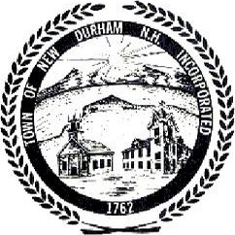
Town of New Durham

Public Notice
Tuesday, July 27, 2010 @ 7 PM @

- Shoreland ordinance
- Agreement with MMRG
- Water sample from mt molly
- Planning for New Durham Day—con comm. Display board
- Beach ordinance
- New/Old Business
- Minutes

Posted 7/30/2026

The Planning Board may enter into Non Public Session, if so voted, under the Terms and Conditions of RSA 91-A:3 II a ~ e and RSA 91-A:2 I c.

