**REPLANTING MONSON TREE COMMITTEE**

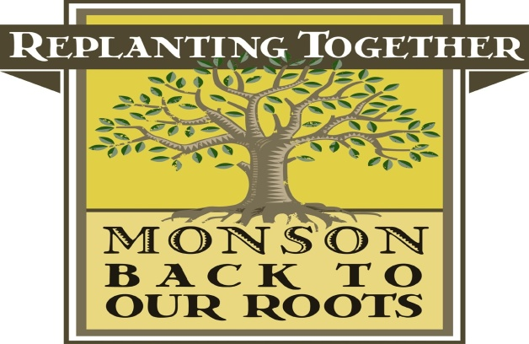

**Minutes of August 11, 2015 Meeting**

Members In attendance: Valarie Beaudoin, Leona Brahen, Bill Dominick and Leslie Duthie

The minutes of the June 9, 2015 meeting were reviewed and, after motion duly made by Ms. Duthie and seconded by Mr. Dominick, were approved.

**Update on TreeCity USA**

Ms. Beaudoin reported that she had attended the Board of Selectmen’s meeting and presented that plague and road signs that were received by the Committee. The signs will be posted in town. She also reported that the TreeCity USA sign may appear in a future edition of the Journal in the “Where Is It” section. She reported that the Committee had been asked to purchase a flagpole for the Selectmen’s meeting room to display the flag that was received from TreeCity. The Committee unanimously approved this recommendation and Ms. Beaudoin will inform the appropriate town representatives of the Committee’s.

**Update on September Event**

A review of the various planting sites for the September 19, 2015 planting that is planned. Ms. Duthie reviewed the grants that had been applied for with the DCR and reviewed the plantings that were involved in those grants, including Memorial Hall.

**Election of Officers**

Ms. Beaudoin reminded the Committee that officer elections needed to be held. After motion duly made and seconded, it was unanimously voted to elect Ms. Valerie Beaudoin as Chairperson, Leona Brahen as Secretary and Leslie Duthie as Treasurer.

Ms. Beaudoin reminded the Committee that the next meeting would be held on September 8, 2015 at 6:00 p.m. at the Town offices.

After motion duly made and seconded, the meeting adjourned at 6:40 p.m.

Respectfully submitted by,

Leona Brahen, Secretary