**REPLANTING MONSON TREE COMMITTEE**

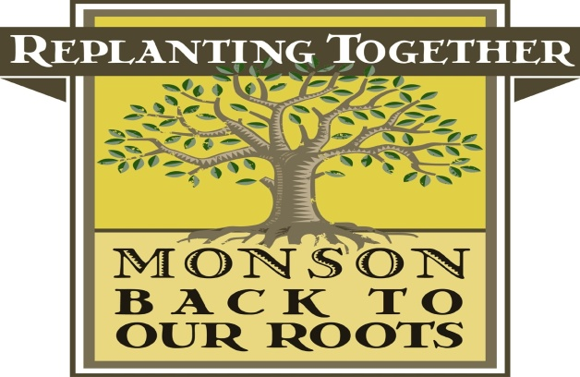

**Minutes of June 9, 2015 Meeting**

Members In attendance: Valarie Beaudoin, Leona Brahen, Bill Dominick and Leslie Duthie

The minutes of the May 12, 2015 meeting were reviewed and, after motion duly made by Ms. Duthie and seconded by Mr. Dominick, were approved.

**Update on Potential State Funding**

Ms. Beaudoin updated the Committee on the potential state funding that Senator Gobi has been working on. The Committee discussed many aspects of the funding, including potential use of the money. It was agreed that additional information would be needed on how the money could be used before the Committee could present a proposal on uses of the funding.

**Update on September Event**

The Committee discussed the various orders that had been received to date. It was agreed that final details of an event would be discussed at the August meeting once we were sure that all orders had been received. The date for the September event was selected and it was decided to hold any potential event on September 19, 2015.

**Update on Monarch Butterfly Garden**

Ms. Duthie indicated that no milkweed was available for this season. This item was tabled for future discussion once a supply of milkweed could be secured.

Ms. Beaudoin and Ms. Brahen announced that the TreeCity USA application had been accepted and that we were expecting a package to arrive in the near future.

Ms. Duthie highlighted the various matching DCR grants that had been applied for including full funding for any plantings at the proposed skate part at Veteran’s field and the plantings at Memorial hall.

The Committee agreed to take the month of July off. Ms. Beaudoin announced that the next meeting of the Committee would be on August 11, 2015 at 6:00 p.m. at the Town offices.

Aer motion duly made and seconded, the meeting adjourned at 7:08 p.m.

Respectfully submitted by,

Leona Brahen, Secretary