**REPLANTING MONSON TREE COMMITTEE**

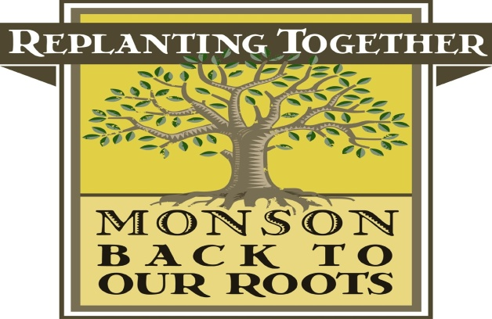

**Minutes of October 14, 2014 Meeting**

Members In attendance: Valarie Beaudoin, Leona Brahen, Bill Dominick, Leslie Duthie, Jo Sauriol and Victoria Prior

The minutes of the September 9, 2014 meeting were reviewed and, after motion duly made by Ms. Duthie and seconded by Mr. Dominick, were approved.

Due to the Veterans’ Day holiday on November 11, 2014, the Committee voted to hold its next meeting on November 18, 2014.

**Fall Planting Review**

Ms. Brahen and Ms. Beaudoin review the fall planting. Ms. Brahen reported that the pruning session contemplated for September 29 was postponed until spring due to a lack of participants. The session will be offered as part of the Committee’s Arbor Day event in the spring.

Ms. Beaudoin reviewed a request for trees from Lincoln Street. Ms. Duthie stated that the relief for the tornado recovery was well on its way to completion and suggested that the Committee consider opening up tree offers for the remainder of town that may have suffered tree damage due to various storms that had occurred over the past several years. The Committee will discuss this at a later meeting.

**Potential Spring Event**

The Committee discussed several options for a spring Arbor Day event, including a fruit tree event. Ms. Sauriol will do a survey from the Monson Speaks Facebook page to determine the interest in the Community for such an event. Ms. Brahen reported that she had received three inquiries as to the fruit tree event as a result of conversations with Brad Medeiros and his crew. The following dates were selected for the Arbor Day event and Ms. Duthie agreed to get a price list from Bigelow so the Committee could review availability of stock.

Ms. Beaudoin also reported that she would be in touch with the Down To Earth Gardeners to gage their interest in helping to maintain the perennial beds at the new Town Office. She would reported back to the Committee at a later meeting.

**Tree City Application**

Ms. Beaudoin reported that she would meet with representatives of the town to preliminarily discuss interest in Monson becoming a Tree City. She will be sure to have us put on the agenda for the Selectmen’s meeting on November 18, 2014. She requested that all Committee members plan on attending the Selectmen’s meeting if possible.

Ms. Beaudoin then outlined the program from “Valley Gives” and indicated that she and Ms. Brahen would be working to try and get us listed on this website. It sponsors a day of giving for non-profit organizations in the Pioneer Valley and would an opportunity for the Committee to raise funds. Ms. Beaudoin will check to be sure that we qualify for representation on the site.

Ms. Beaudoin then mentioned that the Committee might want to consider promoting a writing campaign once the new governor is elected to encourage him to release the bond funds that were earmarked for trees in Monson. This will be discussed at the next meeting of the Committee once it is clear who will the next governor.

The Committee approved several bills from the fall planting. Ms. Brahen reported that there was no correspondence and Ms. Beaudoin mentioned the coverage in the Journal Inquirer that the Committee had received following the fall planting.

After motion duly made and seconded, the meeting adjourned at 7:00 p.m.

Respectfully submitted,

Leona Brahen, Secretary