**REPLANTING MONSON TREE COMMITTEE**

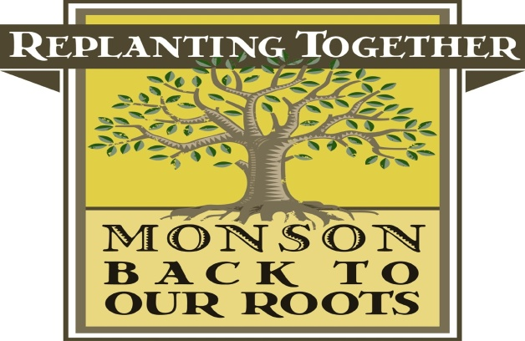

**Minutes of August 12, 2014 Meeting**

Members In attendance: Valarie Beaudoin, Leona Brahen, Bill Dominick, Leslie Duthie, Jo Sauriol and Victoria Prior

Also in Attendance: Mary Watson, Monson Town Clerk

The minutes of the June 9, 2014 meeting were reviewed and, after motion duly made by Ms. Prior and seconded by Mr. Dominick, were approved,

**Swear-In of Committee Members**

Ms. Mary Watson, Town Clerk, swore in members of the Committee and also delivered necessary paperwork that is required by the Town. After completing these duties, Ms. Watson left the meeting.

**Officer Elections**

Ms. Beaudoin then called for a discussion on the slate of officers. She reported that the proposed slate was as follows:

Valerie Beaudoin, Chairperson

Leona Brahen, Secretary

Leslie Duthie, Treasurer

Ms. Prior made a motion to accept the slate of officers, Mr. Dominick seconded and it was voted unanimously to accept same.

**Discussion of White Pine Offer**

Ms. Beaudoin explained that National Grid had been contacted and had no problem with our digging the white pines from under the power lines. However, they did ask that we contact them if large construction equipment would be used. Ms. Duthie is to supply the pots for the trees. Ms. Brahen agreed to post the pictures of the trees and a reminder of the event on Facebook. She also informed the Committee that so far there had been six affirmative responses with regard to interest after she emailed the customer list. It was decided to table the discussion of a time for the event pending a report on the schedule for the September 27 planting date.

**Review of Fall Planting**

Ms. Beaudoin reported that as of the date of the meeting there were no requests for public trees. We will wait until the September meeting to finalize the plans for the planting. Ms. Brahen informed the Committee that Brad Medeiros had been contacted and asked to hold the date for possible help from his crews. The Committee discussed the pruning session and Ms. Brahen suggested that the Committee consider Flynt Park for the location. She indicated that she would post a reminder on Facebook and would contact our customer list to gauge interest in such a session.

Mr. Dominick raised the issue of the Bradford pear trees at Adams. It was agreed that Ms. Beaudoin would follow up with Adams to determine whether they would like the Committee to replace the existing trees with larger trees. It was decided that this would be tabled until the fall planting had been finalized. Mr. Dominick suggested that perhaps it would be better to wait until spring.

Ms. Beaudoin confirmed that $300,000 had been included in the recent bond bill approved by the State. However, we would have to wait until the funds were appropriated to determine the use and amount the disbursement to Monson.

Ms. Brahen reported that there was no correspondence other the six responses received at the Gmail account previously reported. Ms. Beaudoin reported that there were no bills that required Committee approval.

After motion duly made and seconded, the meeting adjourned at 6:45 p.m.