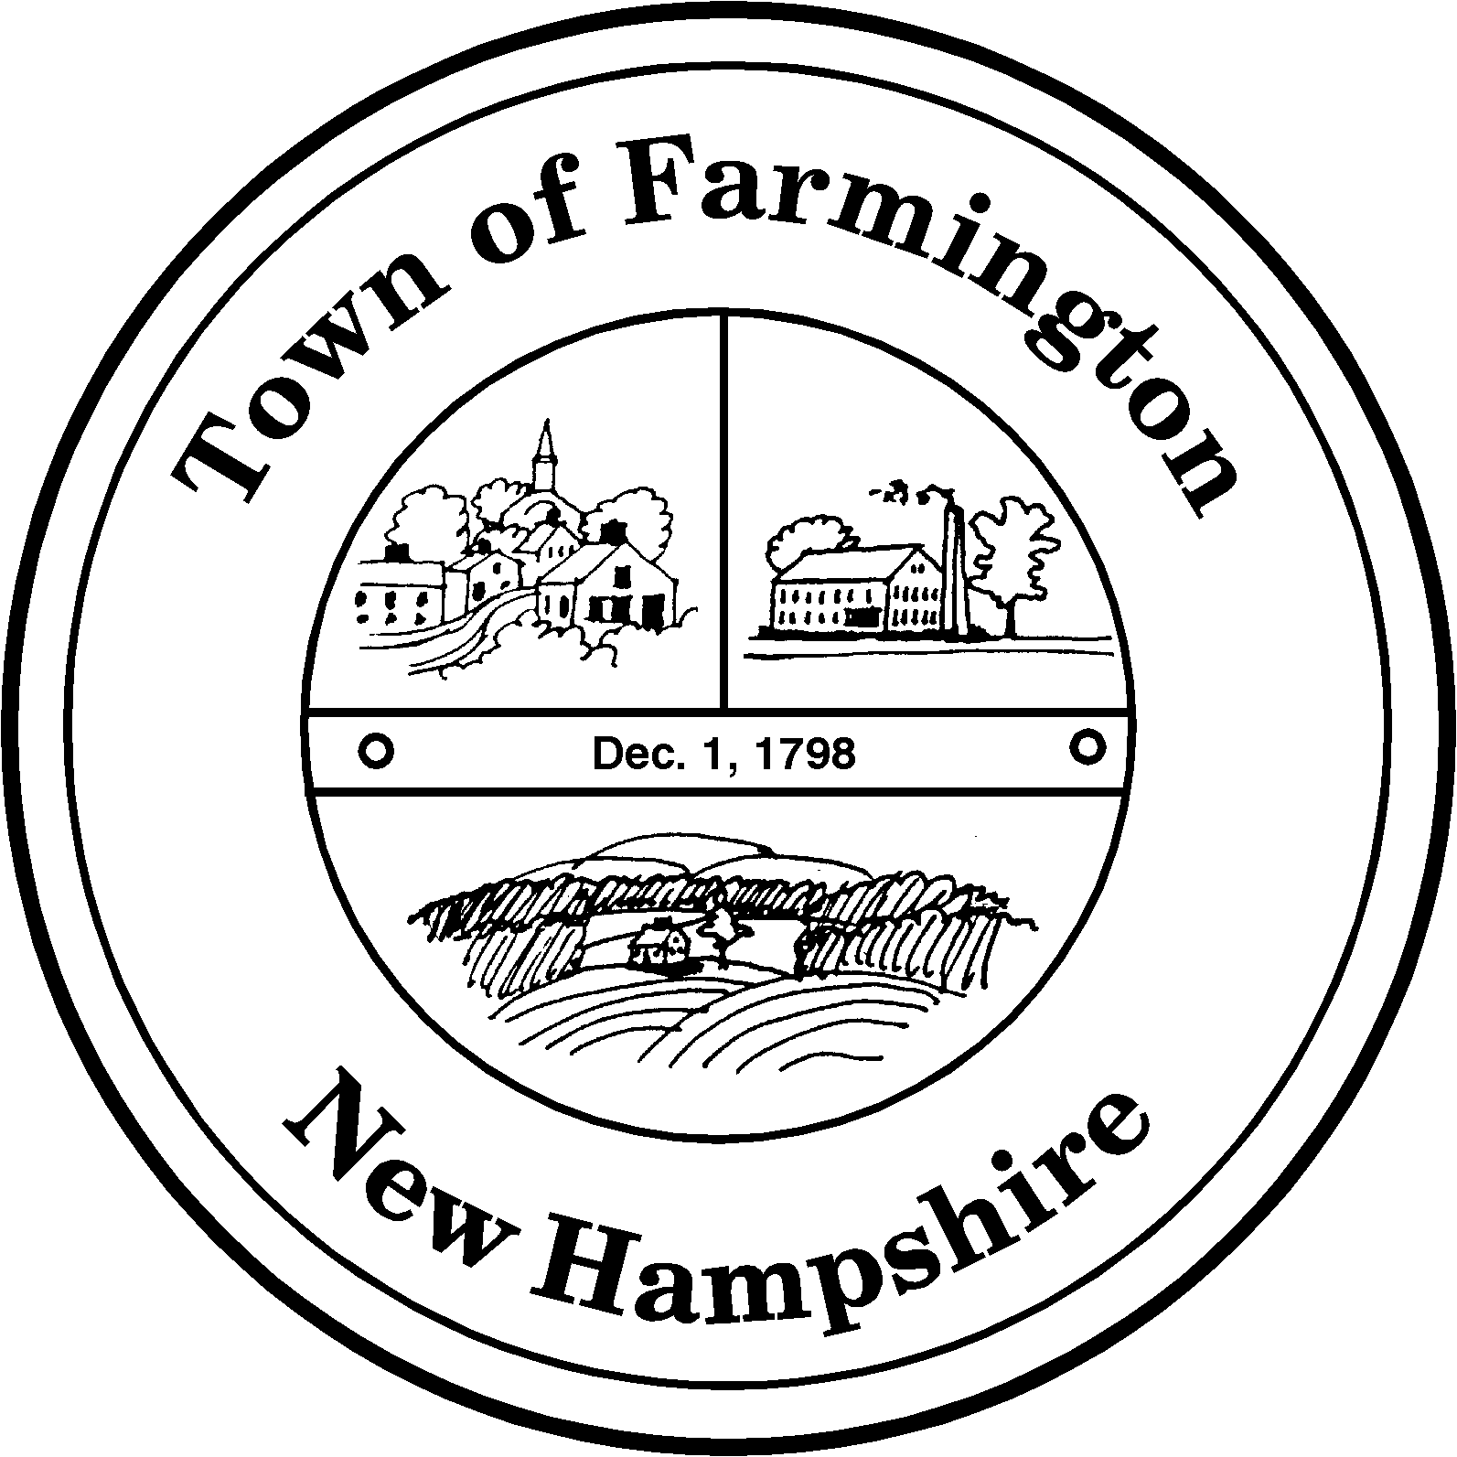
Town of Farmington
Planning and Community Development
356 Main Street
Farmington, NH 03835
Phone: (603) 755-2774
A Bicentennial Community
1798 - 1998

MINOR SITE PLAN REVIEW COMMITTEE

TUESDAY – September 26, 2011

356 Main Street - Farmington, NH

AGENDA - 2:00 pm

            - Application for Minor Site Plan Approval By: Cocheco Veterinary Hospital LLC / Grant Myhre, Applicant, William Harvey, Property Owner (Tax Map R64 Lot 009): To allow the operation of a veterinary hospital in an existing structure. Parcel is located at 1238 NH Route 11 in the Commercial Industrial Business Overlay (CIBO) Zoning District.

Kathy Menici, Planning Director

