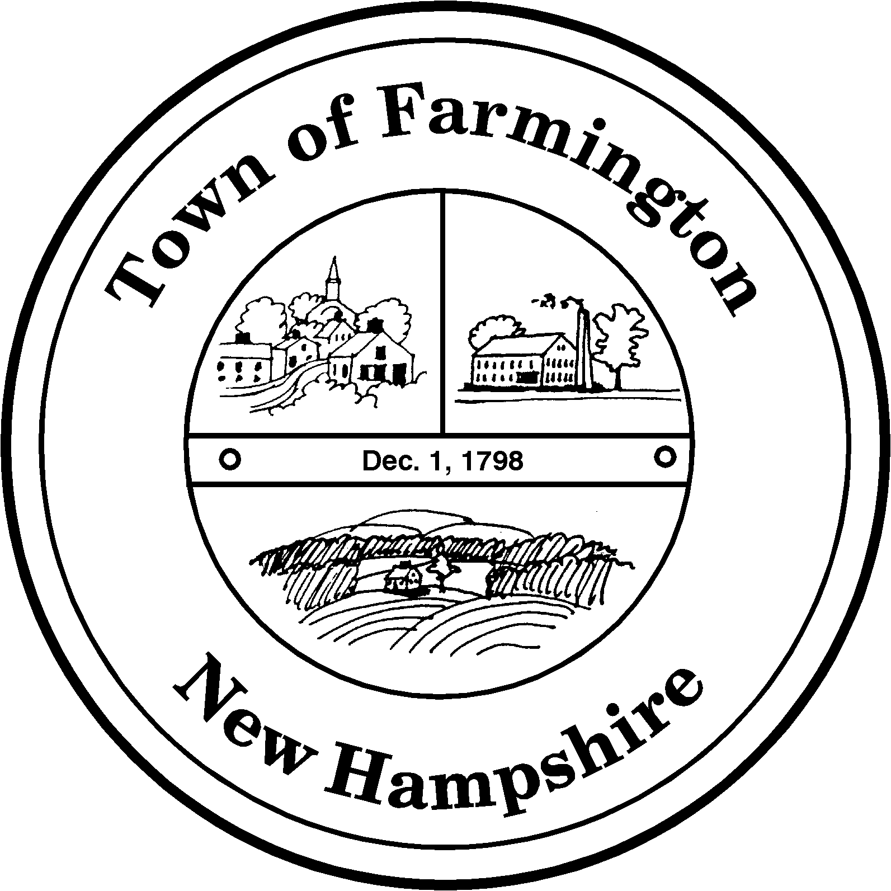
Town of Farmington
Planning and Community Development
356 Main Street
Farmington, NH 03835
Phone: (603) 755-2774
A Bicentennial Community
1798 - 1998

MINOR SITE PLAN REVIEW COMMITTEE

TUESDAY – August 23, 2011

356 Main Street - Farmington, NH

AGENDA - 2:00 p. m.

            - Application for Minor Site Plan Approval By: Kevin Jenckes d/b/a EMS Abounds (Tax Map R64 Lot 3); To allow an office and training school in an existing structure. Parcel is located at 1172 NH Route 11 and in the Commercial Industrial Business Overlay (CIBO) Zoning District.

Kathy Menici, Planning Director

