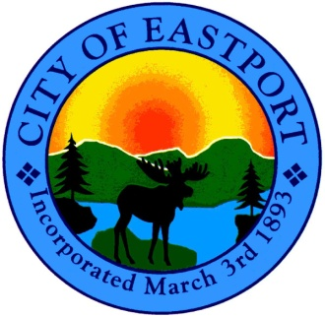

Office of the Phone 207- 853- 2300
City Manager and FAX 207- 853- 4712
the City Council

City Council Meeting
Wednesday, July 24th, 2013
6:00 P.M. - Shead High School - Band Room

- Call to Order

- Public Hearing
▪ Acceptance of “SRF” Award/Loan from Bond Bank - $534,000
(for WWTP/Sewer)

- “Action” on Public Hearing

- Adjourn

