Office of the Phone 207- 853- 2300
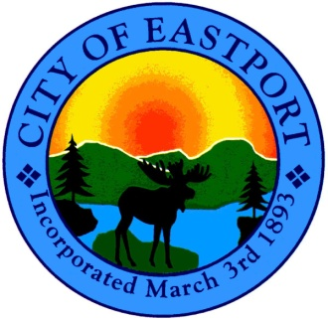
City Manager and FAX 207- 853- 4712
the City Council

CITY COUNCIL MEETING
Wednesday, October 10th, 2012
6:00 P.M. - SHEAD HIGH SCHOOL

Workshop - Vendor Ordinance

Public Hearings

● Zoning Ordinance Amendment (Parking)
● Zoning Ordinance Amendment (Inclusion of 73 Water St. to Historic District Map & Listing)
● Liquor License Application(N) Robert DelPapa d/b/a WACO DINER
● Victualer License(N) Robert DelPapa d/b/a WACO DINER
● Special Entertainment License(N) Robert DelPapa d/b/a WACO DINER

Regular Monthly Council Meeting - 6:00 p.m.

1. Call to Order

2. Adjustments to Agenda

3. Action on Public Hearings (if applicable)

4. Minutes of Meetings
● 8/7/2012 - Council Meeting
● 9/12/2012 - Council Meeting

5. Department Reports

● Financial Report - Code Enforcement & Assessor Reports
● Police Department Report - Public Works Report - Sewer Report
● Port Report/Update

6. Boards and Committees - Reports & Appointments

● Planning Board - ZBA - Historic Review Board
● Airport - Harbor - Downtown - Charter Committee

7. Appointment of Council Liaison to Charter Committee

8. Commitment of Sewer Fees to City Treasurer for 2nd Quarter of FY2013

9. Adopt 2012-2013 General Assistance Appendices (C)

10. Sign Warrant for November 6th, 2012 Municipal Election

11. Sale of City Property
● 1 Jensen St. (Tax Map #E2-0B4-01)
● 1 Byrd St. (Tax Map #E3-0A1-02)
● 1 Deeks St. (Tax Map #E3-0A2-07)
● 23-24 Mitchell St. (Tax Map #H7-0C3-08/8A)
● 10 Favor St. (Tax Map #H7-0C4-17)
● 1 Toll Bridge Rd. (Tax Map #D1-0B4-2A)

12. Marion Transfer Update

13. Ambulance Update

14. Scheduling of Public Hearings/Workshops/ Special Meetings (if applicable)
● PH – Liquor License to Accommodate the Expansion of the Liberty Café for Tyra Baker (11/14/12)

15. CITY MANAGER’S ISSUES
● Fire Station Update ● Sewer Plant Update
● Election Nomination Papers Update

16. OPEN FORUM (Will be held at 8:00 when meetings extend beyond)

17. EXECUTIVE SESSION (if applicable)
● Legal & Personnel Issues

18. ADJOURNMENT

