Office of the Phone 207- 853- 2300
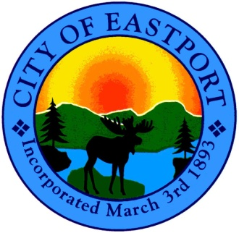
City Manager and FAX 207- 853- 4712
the City Council

CHARTER COMMITTEE
“WORKSHOP”
Tuesday, August 15th, 2012
7:00 P.M. - SHEAD HIGH SCHOOL

WORKSHOP - 7:00 P.M.

- Call to Order

- Appointment of a Chairperson to the Charter Committee

- Introduction to the City’s current City Charter

- Orientation & Purpose

- Adjourn

