Board of Selectmen
Town of East Windsor
11 Rye Street
East Windsor, CT

MINUTES OF REGULAR MEETING, September 7, 2010 at 7:00 p.m.

These minutes are not official until approved at a subsequent meeting.

Members Present: Denise Menard, Mark Simmons, John L. Burnham, Gilbert Hayes, and Richard P. Pippin, Jr.
Members Absent: None
Others: Jack Mannette, Robert Little, Marie DeSousa, Kathleen Pippin, Danelle Godeck, Jason Bowsza, Paul Anderson, Catherine Cabral, Laurie P. Whitten, Mark Lucia, E. Arthur Endrele III, and Edward Alibozek
Press: K. Loucks (Journal Inquirer)

- Call to Order

First Selectwoman Denise Menard called the Regular Meeting to Order at 7:00 p.m., in the East Windsor Town Hall.

- Attendance

Denise Menard, First Selectman
Mark Simmons, Deputy Selectman
John L. Burnham, Selectman
Gilbert Hayes, Selectman
Richard P. Pippin, Jr., Selectman

It was MOVED (Pippin) and SECONDED (Simmons) and PASSED (U) that the Board of Selectmen agree to move the discussion of Agenda Item VIII. New Business (C) Update regarding the North Road Sewer Project and possible approval of funding Resolution to be done before III. Approval of Minutes.

VIII. New Business

C. Update regarding the North Road Sewer Project and possible approval of Funding Resolution

First Selectwoman Denise Menard discussed the update regarding the North Road Sewer Project. She indicated the USDA has been informed that the town needs to hold a referendum concerning the funding of the project. The USDA has no issue with this requirement of the town. The town has requested three bids for bound counsel and has appointed counsel for same. Another question regarding the referendum was posed regarding having the referendum during the general election or having the referendum done in a special election. It was felt by the majority the sooner the better for having the referendum in October and to have the referendum done separate from the general election due to the fact the question would be placed the last one on the ballet and voters tend not to care about the last question. It has been determined that appropriation and bond authorization should be in the amount of $3,950,000 for the North Road Sewer Project. She discussed the Proposed Resolution in detail paragraph by paragraph. She indicated the Board of Finance will have to also approve and sign a Resolution before the referendum can scheduled and due to the timeframe caused by the Charter, it has to be done in 30 days. Another concern regarding the timeframe is the requirement of voting machines being locked fifteen days before an election. The Secretary of State’s office has been contacted regarding the fifteen day requirement, and it has been confirmed there is no requirement; however, it was recommended seven days in case of a recount. The referendum is scheduled for October 13, 2010. There was some confusion as to which time the polls would be open either at 6:00 a.m. to 8:00 p.m. or at 12:00 p.m. to 8:00 p.m.

Chairman of the Board of Finance, Jack Mannette, had a question regarding the resolution. At the Town Meeting wherein this project was discussed, it was indicated the funding would be approximately $2.1 Million and the grant would be in the amount of $1.7 Million. He does not understand why the bond authorization has to been $3.9 Million. Ms. Menard explained the borrowing will be short term and the Town cannot borrow more than the $3.9 Million, but can use less than that figure.

A brief discussion among Ms. Menard, Mr. Mannette, Mr. Anderson, and Mr. Burnham was held regarding the appropriations and bond authorizations, and zoning requirements.

It was MOVED (Burnham) and SECONDED (Hayes) and PASSED (U) that the Board of Selectmen adopts Resolution known as Exhibit A, as presented.
Board recessed at 7:28 p.m.
Board reconvened at 7:34 p.m.

- Approval of Minutes

Minutes of August 17, 2010 Regular Meeting

An error was noted in the August 17, 2010 Regular Meeting Minutes. An amendment to the minutes on Page 2, Section V, Paragraph 2 is noted. The following is the noted amendment:

“Ms. Dale Nelson, 51 Amelia Road, addressed…”
to
“Ms. Dale Nelson, 51 Amolia Road, addressed…”
and
“…the sewer project has gone threw.”
to
“…the sewer project has gone through.”

An error was noted in the August 17, 2010 Regular Meeting Minutes. An amendment to the minutes on Page 4, Section VII, Subparagraph b, Paragraph 1 is noted. The following is the noted amendment:

“…the Veteran’s Commission does not meeting.”
to
“…the Veteran’s Commission did not meet.”

An error was noted in the August 17, 2010 Regular Meeting Minutes. An amendment to the minutes on Page 4, Section VII, Subparagraph b, Paragraph 3 is noted. The following is the noted amendment:

“Parks and Recreation Commission had…”
to
“BMX had…”

It was MOVED (Burnham) and SECONDED (Simmons) and PASSED (U) that the Board of Selectmen approves the minutes of August 17, 2010 Regular Meeting, as amended.

- Public Participation

Mr. Edward Alibozek, Chief Operator of WPCA, addressed the Board. He wanted to thank the Board of Selectmen for their continued unified support of the WPCA and North Road Sewer Project.

- Communications

  - The Sports Department Newspaper

Ms. Menard showed the Board Members a copy of the Sports Department Newspaper. Ms. Melissa Maltese of Parks and Recreation has been looking for ways to get the Parks and Recreation news published. She has gotten East Windsor events published in the North Central News, Reminder Press, and Journal Inquirer. This newspaper solely reports on sports news. The printing of the newspaper is paid by advertisers. Ms. Menard thanked Ms. Maltese for all of her hard work.

  - Correspondence from Andy Hoffman regarding the North Road Sewer Project

Ms. Menard indicated she received a letter dated August 12, 2010 from Mr. Andy Koffman of Graham Road congratulating the Town for all of their hard work in regards to the North Road Sewer Project. Ms. Menard read from the letter.

c. Thank you letter from WPCA to the First Selectman’s Staff

Ms. Menard commented about a letter which was sent by Mr. Edward Alibozek, Chief Operator of the WPCA thanking Ms. Becky MacDonald and Ms. Jennifer Browne for their assistance in the past year in helping him with whatever materials, research, collecting data, and legalities of legal notices and town meetings, among other things. He appreciates their willingless to offer support.

- Selectmen’s Reports

  - Denise Menard, First Selectwoman

Ms. Menard indicated she did not have a report for this meeting due to the fact she has been working on many different projects and has been unable to compile a report for this meeting. Her time has been consumed with the North Road Sewer Project, Millbrook information sessions, and internal issues.

  - Mark Simmons, Deputy First Selectmen

He indicated the BMX Commission meets once a month. Veteran’s Road Race Day is scheduled for Veteran’s Weekend on November 13, 2010. Two hundred and fifty runners are expected. He hopes all can take part and the weather will cooperate.

Mr. Simmons commented on the Korean War Veterans Public Service Awards. The ceremony will be similar to the one held for World War II Veterans. The Town is presently searching for citizens who are veterans of the Korean War.

Economic Development Commission did not met in August.

He indicated the Chamber of Commerce has many meetings planned, on September 23 at La Notte Restaurant and on September 21, an In Your Face Networking luncheon. He also mentioned the German Club will be having a golf tournament on September 26, 2010 to raise money for schools and other services for the Town.

He also mentioned a tribute to a young man, Mario Acquina, a graduate of East Windsor High School, who is not a life guard; however, saved the life of an l4 year old swimmer. He showed the Board Members a copy of the article which was in the Journal Inquirer.

  - John L. Burnham, Selectmen

Mr. Burnham mentioned the farewell dinner of Mr. Timothy Howes, Superintendent of Schools, which was well attended. He discussed the River Commission next trip on September 11, 2010 and invited all to attend and indicated the next meeting in October will be considered a work day. He commented that the Scout Hall Pavilion has been completed.

  - Gilbert Hayes, Selectmen

Mr. Hayes indicated the fireman’s incentive program is at $12.00 per call. Te Fire Departments are working within their budgets and hopefully, the extra $2.00 per call will put the Department’s budget.

He commented about the Connecticut Water Company sent him an invitation for high school seniors who are not planning to attend college after graduation, to attend a job fair at the facility. He indicated he gave the information to the Board of Education to forward to the Guidance Department at the high school. Unfortunately, no one went to the job fair from East Windsor High School. He also mentioned the farewell dinner for Mr. Timothy Howes which was well attended. He commented the leaving of Mr. Howes to the school system is a big loss and he will be hard to replace.

  - Richard P. Pippin, Selectmen

Mr. Pippin commented that the Building Commission did not meet last month. The Inland Wetland Commission Meeting took place which 161 South Main Street was discussed. Also was discussed the water quality on Route 5 and having to recreate wetlands, which is all EPA approved. Mr. Pippin also commented on the Broad Brook Mill clean-up and the WPCA Sewer Project. He hopes the financing goes through for the North Road Sewer Project.

- Board and Commission Resignations and Appointments

  - Resignations:

      - William G. Raber, Parks and Recreation Commission

Mr. Raber in a letter dated August 27, 2010, resigned from the East Windsor Parks and Recreation Commission for personal reasons.

It was MOVED (Pippin) and SECONDED (Burnham) and PASSED (U) that the Board of Selectmen accepts the resignation of Willian G. Raber, Parks and Recreation, with deep regret.

      - Mark Simmons,
Capital Improvement Planning Advisory Committee

Mr. Simmons in a letter dated August 26, 2010, resigned from the East Windsor Capital Improvement Planning Advisory Committee for personal reasons.

It was MOVED (Burnham) and SECONDED (Pippin) and PASSED (U)(M. Simmons abstained) that the Board of Selectmen accepts the resignation of Mark Simmons, Capital Improvement Planning Advisory Committee, with deep regret.

      - Mark Simmons, Veteran’s Commission

Mr. Simmons in a letter dated August 25, 2010, resigned from the East Windsor Veteran’s Commission for personal reasons.

It was MOVED (Hayes) and SECONDED (Pippin) and PASSED (U)(M. Simmons abstained) that the Board of Selectmen accepts the resignation of Mark Simmons,
Veteran’s Commission, with deep regret.

      - Philip Godeck, Water Pollution Control Authority

Mr. Godeck in a letter dated August 18, 2010, regained from the East Windsor Water Pollution Control Authority for personal reasons.

It was MOVED (Burnham) and SECONDED (Simmons) and PASSED (U)(R. Pippin abstained) that the Board of Selectmen accepts the resignation of Philip Godeck, Water Pollution Control Authority, with deep regret.

  - Re-Appointments: None
  - New Appointments:

American Heritage River Commission
Gilbert Hayes, (D) as a regular member to serve a four-year term to expire September 1, 2015.

It was MOVED (Burnham) and SECONDED (Pippin) and PASSED (U)(G. Hayes abstained) that the Board of Selectmen approves the appointment of Gilbert Hayes, (D) to serve a four-year term to expire September 1, 2015.

Water Pollution Control Authority
Richard P. Pippin, III (R) to serve a four-year term to expire December 1, 2013.

It was MOVED (Pippin) and SECONDED (Burnham) and PASSED (U)(R. Pippin abstained) that the Board of Selectmen approves the appointment of Richard P. Pippin, III (R) to serve a four-year term to expire December 1, 2013.

  - Board and Commission Current Vacancy List

The list was given to all the Board Members for their review.

- New Business

  - Discussion of filling Part-Time Clerk Vacancy in the Planning and Development Office

Ms. Menard introduced to the Board Ms. Laurie P. Whitten, Director of Planning and Development. She indicated on August 17, 2010, she has requested filing a part-time clerk vacancy, which has been fully funded for over a year. The position was originally created as support for the wetlands officer. When the departments merged, the part-time clerk assisted with all aspects of the land use department. Due to the understanding of economic times, and the diminished number of applications, the staff accepted the situation and has tried to cover all of the tasks. However, at this time, Ms. Whitten is requesting the position be filled due to the increased number of tasks.

A discussion was held among the Board Members and Ms. Whitton regarding the cost of the position and the reasons why the position is needed.

It was ultimately decided that more research has to be done before the authorization for filling the part-time clerk position could be done. The matter was postponed for two weeks.

  - Request Approval of State of Connecticut Department of Emergency Management and Homeland Security Resolution

Ms. Menard gave a copy of the Resolution establishing the First Selectmen may enter into with and deliver to the State of Connecticut Department of Emergency Management and Homeland Security any and all documents which is deemed necessary and the First Selectman is authorized and directed to execute and deliver any documents on behalf of the Town of East Windsor and to do and perform all acts which is necessary or appropriate to carry out the terms of such documents.

A brief discussion was held regarding the proposed resolution.

It was MOVED (Pippin) and SECONDED (Simmons) and PASSED (U) that the Board of Selectmen adopts Resolution known as Exhibit B, as presented.

It was MOVED (Pippin) and SECONDED (Simmons) and PASSED (U) that the Board of Selectmen agree to move the discussion of Agenda Item X. Budget Matters (A) Monthly Transfers to be done before VIII. New Business (d) Discussion of Town Property Leases/Agreements.

X. Budget Matters

- Monthly Budget Transfers

The Board was given a list of Budget Transfers for 2010-2011 and year end transfers for 2009-2010 for their review.

The first transfer discussed was the Fire Department Request to transfers a total of $27,99l from the CIP budget. It was discussed by two gentlemen representing the Fire Departments the reason for the requested transfer. The transfer is for Broad Brook Fire Department extrication equipment. The current extrication equipment is outdated and needs to be replaced. Ms. Menard explained the process of transferring funds, which includes going to the Board of Finance to get approval.

A discussion was held among the Board Members regarding fire department equipment, transfer process, and availability of grants.

A motion was entertained by Mr. Gilbert Hays and seconded by Mr. John Burnham to recommend the transfer of $27,000 for extrication equipment from CIP 2010-2011 as listed on Exhibit C, as presented, and recommend to a town meeting if necessary.

A discussion was held. Mr. Pippin had an objection to the transfer indicating he would like to have more than one quote for the equipment to confirm the price is the best price to be had for the equipment. It was explained to Mr. Pippin that only two companies supply such equipment, and the departments would like to have all of the equipment to come from the same company.

A vote was taken and it was passed unanimously.

The next transfer discussed was a request from the police department regarding the IT line. This is a new line in the budget and it will be used for purchasing of new equipment for the IT department at the police station.

It was MOVED (Hayes) and SECONDED (Pippin) and PASSED (U) that the Board of Selectmen recommends to the Board of Finance the transfer of $14,000 to a new IT line in the police department budget, as listed on Exhibit C, as presented, and recommend to a town meeting if necessary.

The next set of transfers are year end transfers from 2009-2010. The first transfer listed is to Probate Court from CRCOG in the amount of $10.00 to balance the account.

It was MOVED (Burnham) and SECONDED (Pippin) and PASSED (U) that the Board of Selectmen recommends to the Board of Finance the transfer of $10.00 to the Probate Court Line from CRCOG, as listed on Exhibit D, as presented, and recommend to a town meeting if necessary.

The second transfer listed is for fire protection in the amount of $12,683.00 from the workers’ compensation line. The transfer is the cost of water for the hydrants.

It was MOVED (Pippin) and SECONDED (Burnham) and PASSED (U) that the Board of Selectmen recommends to the Board of Finance the transfer of $12,683.00 to the Fire Protection Line from Workers Compensation, as listed on Exhibit D, as presented, and recommend to a town meeting if necessary.

The last transfer listed is for Public Works Road Improvements CNR from Road Improvements. This is a year end transfer in the amount of $81,516.83.

It was MOVED (Pippin) and SECONDED (Burnham) and PASSED (U) that the Board of Selectmen recommends to the Board of Finance the transfer of $81,516.83 to the Public Works Road Improvements CNR from Road Improvements, as listed on Exhibit D, as presented, and recommend to a town meeting if necessary.

- Discussion of Town Property Leases/Agreements

Ms. Menard gave to all the Board Members a sheet regarding all of the real estate which is leased from the Town of East Windsor including location, renters, cost, expiration of leases, and what the land is currently being used for. Along with the spreadsheet, Ms. Menard also gave each Board Member a copy of Board of Selectmen Minutes of April 18, 2006 wherein the leases were discussed.

A brief discussion was held.

It was MOVED (Pippin) and SECONDED (Simmons) and PASSED (U) that the Board of Selectmen approves the current fee schedule for real estate dated May 4, 2010.

  - Tax Refunds

Ms. Menard discussed an Application for Refund request from the Tax Collector dated September l, 2010 wherein Ms. Samantha Lee, Tax Collector is requesting under Connecticut General Statutes Section 12-129 a refund from the Town of East Windsor in the amount of $6,261.61.

It was MOVED (Pippins) and SECONDED (Burnham) and PASSED (U) that the Board of Selectmen approves the tax refunds in the amount of $6,261.61 pursuant to the tax collector’s request of September l, 2010.

- Unfinished Business

  - Discussion of Property Maintenance Code/Possible Blight Ordinance

Ms. Menard indicated that Mr. Lucia and Mr. Burnham has been working diligently on the property maintenance ordinance. Suggestions have been made that complaints can be filed at the Town Hall; however, complaints which are done anonymously will not be entertained. She introduced Mr. Lucia to the Board. He has given to all Board Members a very rough draft of the Anti-Blight Ordinance. He has done research using at least eight areas and shoreline town codes from towns similar to East Windsor. He has taken into consideration residential, commercial, and farming communities to make the ordinance fair.

A discussion was held regarding the rough draft which was presented and it was agreed that this subject would be revisited in a few weeks to discuss what the committee members have suggested regarding the blight ordinance.

Board recessed at 9:17 p.m.
Board reconvened at 9:30 p.m.
  - Discussion of Removal Process from Board and Commission, in accordance with W.W. Town Charter, Section 7.1

Ms. Menard discussed a new ordinance which would govern the removal process of a Board or Commission Member. Apparently, the Economic Development Commission has a member which never attends the meetings. The Commission has asked him to resign numerous times; however, that particular member has not resigned. Ms. Menard read from the new Charter. She also read from the proposed ordinance regarding the reasons in which a member can be removed. Research of similar ordinances from surrounding towns has been done and some of that language has been incorporated into the proposed ordinance.

A discussion was held among all Board Members reading the proposed ordinance paragraph by paragraph. Comments were made regarding elected Boards versus appointed Boards how this proposed ordinance would only apply to the appointed positions and not elected. After a brief discussion, it was agreed to make any applicable changes and this ordinance will be revisited at a future meeting.

XI. Executive Session Continued (pursuant to Connecticut General Statutes Section 1-200(6) (e) Personnel Matters – Pre-litigation).

Ms. Menard indicated the Executive Session scheduled for this meeting will be rescheduled next week.

- Adjournment

It was MOVED (Simmons) and SECONDED (Pippin) and PASSED (U) that the Board of Selectmen adjourns the September 7, 2010 Regular Meeting at 9:51 p.m.

Respectfully Submitted,

Denise M. Piotrowicz
Recording Secretary

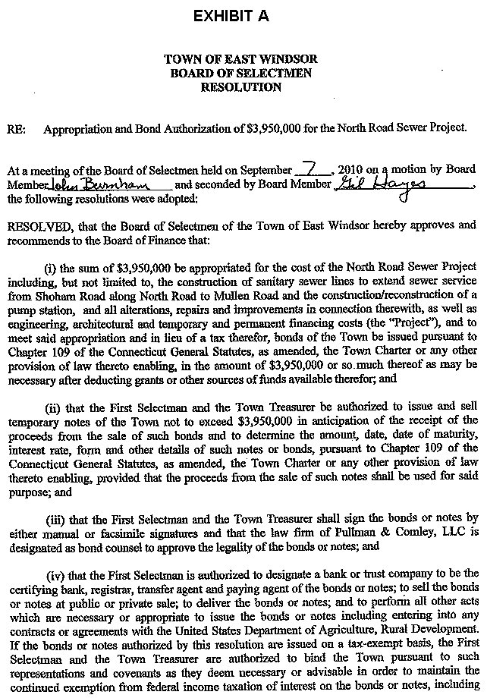
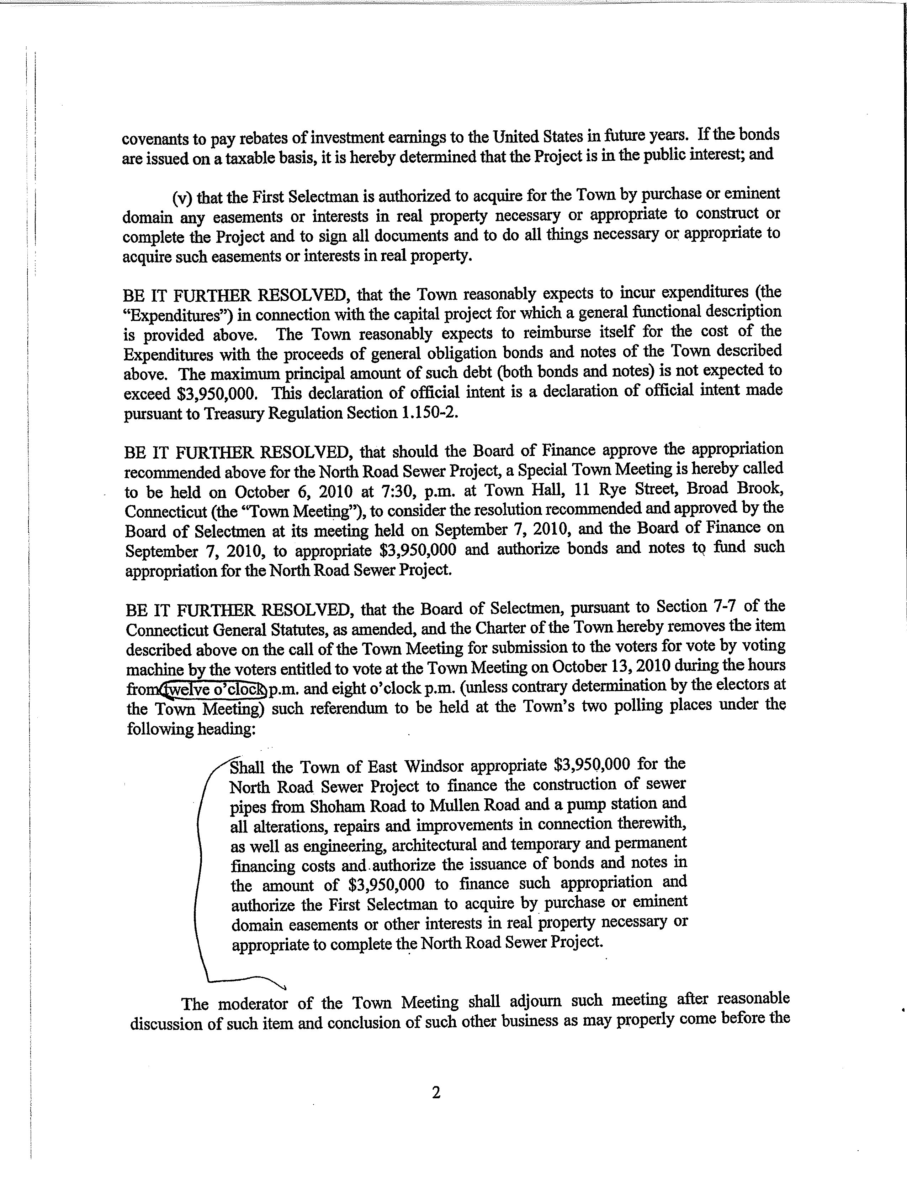
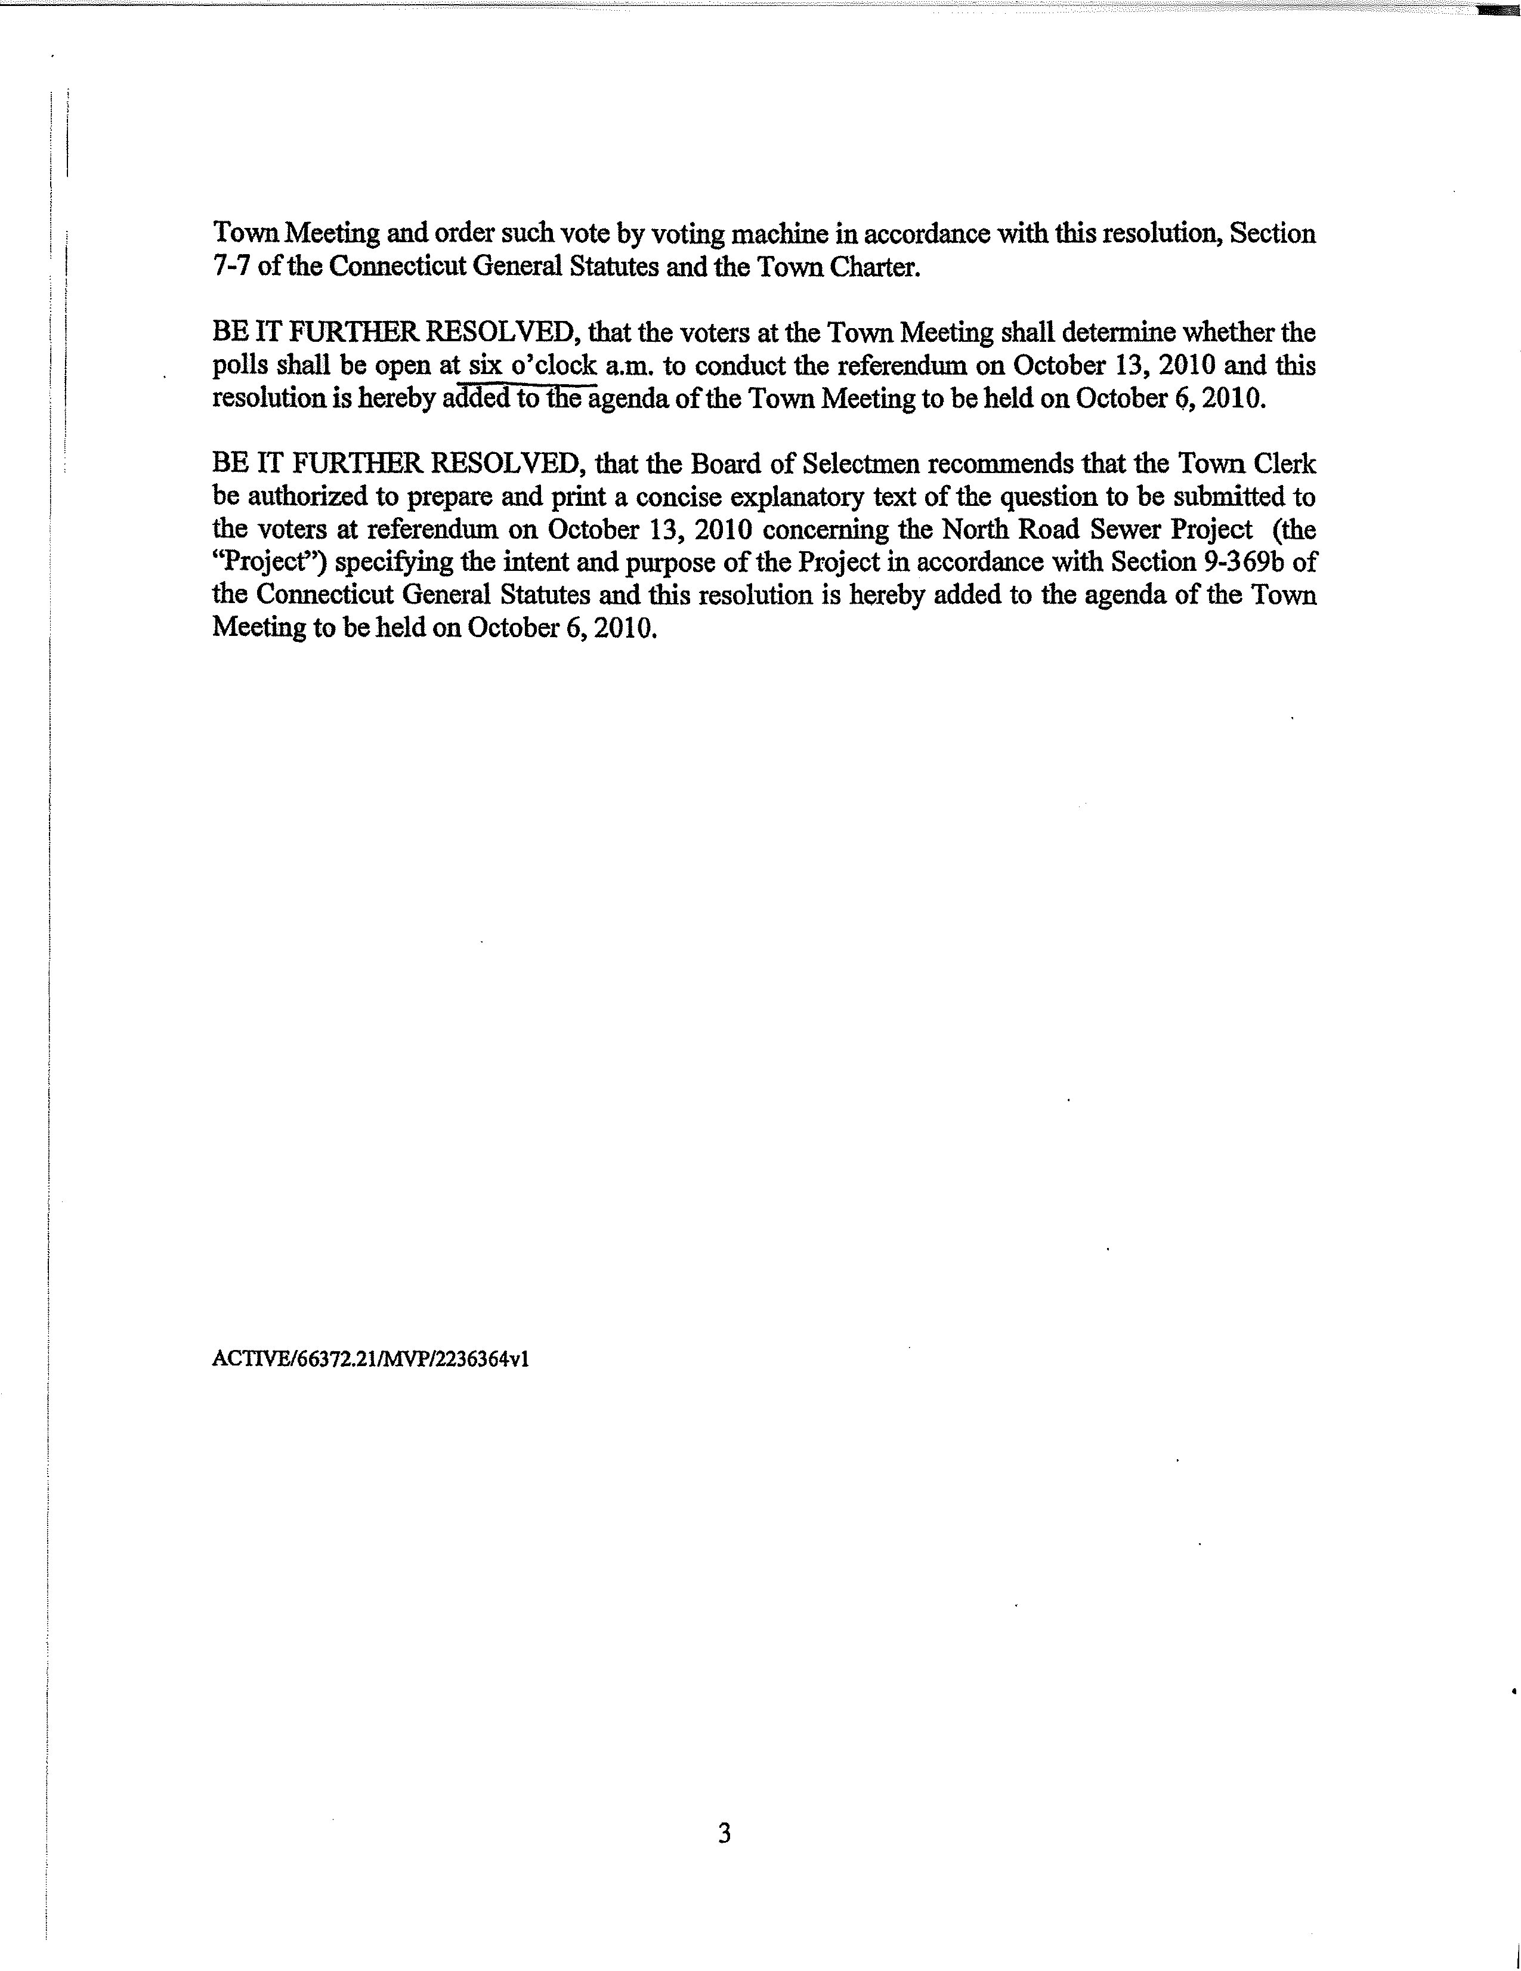

EXHIBIT B

AUTHORIZING RESOLUTION OF THE
TOWN OF EAST WINDSOR, BOARD OF SELECTMEN

CERTIFICATION:

I, Joanne Slater, the Town Clerk of the Town of East Windsor, do hereby certify that the following is a true and correct copy of a resolution adopted by the Board of Selectmen at its duly called and held meeting on September 7, 2010, at which a quorum was present and acting throughout, and that the resolution has not been modified, rescinded, or revoked and is at present in full force and effect:
RESOLVED, that the First Selectman may enter into with and deliver to the State of Connecticut Department of Emergency Management and Homeland Security any and all documents which it deems to be necessary or appropriate; and

FURTHER RESOLVED, that Denise Menard, as First Selectman of Town of East Windsor, is authorized and directed to execute and deliver any and all documents on behalf of the Town of East Windsor and to do and perform all acts and things which he/she deems to be necessary or appropriate to carry out the terms of such documents, including, but not limited to, executing and delivering all agreements and documents contemplated by such documents.

The undersigned further certified that Denise Menard now holds the office of First Selectman and that he/she has held that office since November of 2007.

IN WITNESS WHEREOF: The undersigned has executed this certificate this _____ day of September, 2010.

Joanne Slater, Town Clerk

EXHIBIT C
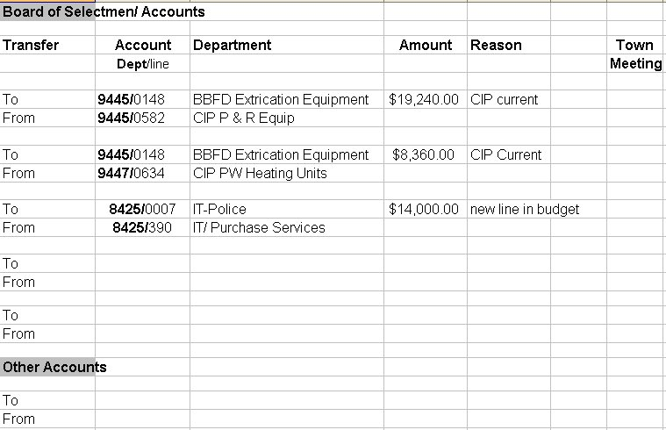

EXHIBIT D
