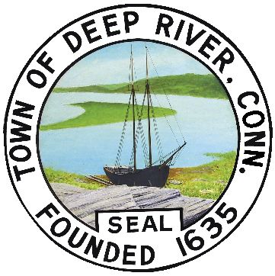

BOARD of SELECTMEN

DEEP RIVER TOWN HALL

XX Regular Meeting Special Meeting

Date: April 14, 2015 Time: 6:30 PM

AGENDA:

1. Call to Order.

2. Approve minutes from regular meeting held on March 24, 2015.

3. Discuss and act on request from John Olson to purchase property from the
Town of Deep River, Plattwood Park.

4. Update Board of Selectmen on town projects.

5. Audience of Citizens – Any other business to come before the Board.

6. Adjournment.

RHS/ggs

