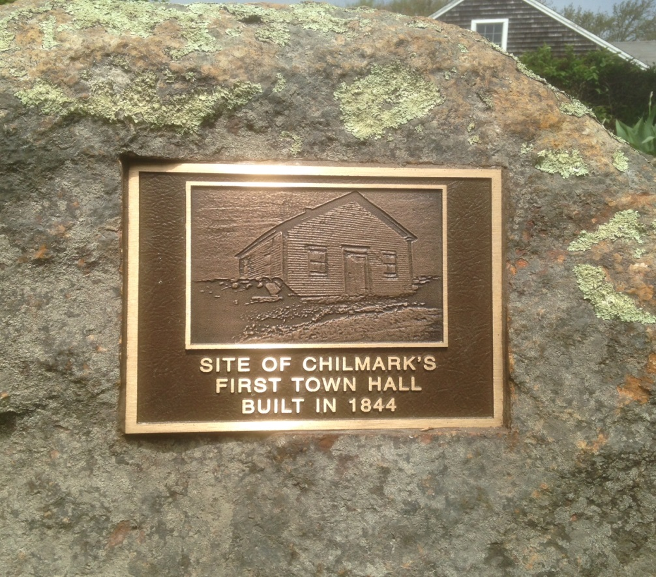

**June 16, 2016**

**This was Chilmark’s first Town Hall. It stood on the Middle Road just over the rise of Bassett’s Hill. The land on which it stood was given to the town by Captain Nathan S. Bassett.**

**It was built in 1844. Before that town meetings were held in the Congregational Meeting House which stood on high land between the Middle and South roads overlooking Abel’s Hill and the ocean. The building was also used for some years as a private boys school by Beriah T. Hillman of Chilmark who later became known as one of the island’s best remembered jurists.**

**In 1897 when the present town hall was built, the old building – which was pretty well run down, and sometimes referred to as “woodpecker hall” – was sold to E. Elliot Mayhew, then Chilmark’s postmaster and principal storekeeper. He had it moved to Chilmark Center where he used it in the construction of his barn.**

**There is a picture of the original town hall at its Middle Road location hanging in Town Hall. The reverse side of this identifies where this plaque will be placing in the stone wall at the original site. You will see a gap in the stone wall which is where the town hall building was placed.**