Town of Brookfield
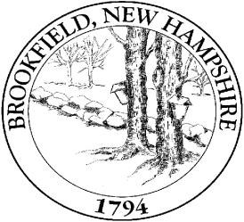
267 Wentworth Road Brookfield, NH 03872
Board of Selectmen
Meeting Agenda

Date: December 30, 2014

6:30pm Meeting Called to Order

- Pledge of Allegiance
- Bills & checks
- Correspondence
- Public Comments
- 2015 Proposed Budget Review

Public Comments

Next Brookfield Selectmen Meeting: January 13, 2015 The Board
of Selectmen meet on the 2nd and 4th Tuesday of each month (unless otherwise noted).
Additional Meetings are scheduled as needed.

