**Town of Brookfield**

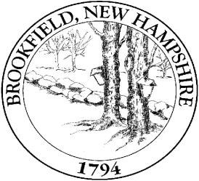**267 Wentworth Road Brookfield, NH 03872**

**Board of Selectmen**

**Meeting Agenda**

**Date: December 16, 2014**

6:30pm **Meeting Called to Order**

1. Pledge of Allegiance
2. Scheduled Speaker: 1) Jack Drinkwater of Medication Bridge@ Huggins Hosp

2) Soil Scientist- Adam Doiron from Doiron Environmental Services

1. Correspondence
2. Approval of Minutes: n/a
3. Public Comments

7:30 **Reports of Town Officials**

1. Treasurer
2. Tax Collector
3. Administrative Assistant/Assessor Clerk
4. Planning Board
5. Code Enforcement Officer/ Road Agent
6. Conservation Commission-
7. Emergency Management Director
8. Forest Fire Warden-
9. Heritage Commission
10. Cemetery Trustees
11. Town Clerk
12. Website Statistics Quarterly- next update Dec.
13. Others Board/Committees

8**:**00 **Old Business-**

8:30 **New Business** –

8:45 **Public Comments**

**Bills**

**Non-Public Session**\* Non-Public Meetings: Per RSA 91-A (if needed) **Adjourn**

**Next Brookfield Selectmen Meeting:**

The Board of Selectmen meet on the 2nd and 4th Tuesday of each month (unless otherwise noted).

Additional Meetings are scheduled as needed.