Village Board of Trustees
Regular Meeting
March 2, 2016
8:00 p.m.

The Regular Meeting of the Board of Trustees of the Village of Briarcliff Manor, New York was held in the Village of Briarcliff Manor Village Hall, at 1111 Pleasantville Road, Briarcliff Manor, New York on the 2nd of March, 2016 commencing at 8:00 p.m.

Present
Lori A. Sullivan, Mayor
Mark Pohar, Deputy Mayor
Cesare DeRose, Jr. Trustee
Mark L. Wilson, Trustee
Bryan Zirman, Trustee

Also Present
Philip Zegarelli, Village Manager
Christine Dennett, Village Clerk
Clinton Smith, Village Counsel

Board of Trustees Announcements by Trustee Wilson

- The Board welcomed Troop 18 of Briarcliff to the meeting.
- The Library has many upcoming programs and events. Visit their website for more information.
- In February the Fire Department had 32 calls and 38 EMS calls.
- Narcan is now on the ambulances.
- Ossining is covering the EMT services
- Day camp dates are set for 2016
- A multi-sport camp will be offered.
- The Recreation Spring brochure will be out shortly.
- All residents are encouraged to sign up for the weekly email blast. Contact Village Clerk to be added. Keep yourself informed.

Village Managers Report by Village Manager Zegarelli

- Law Park update: The roof was demolished and the bathhouse level will begin soon and will be open for Memorial Day.
- The Recreation Advisory Committee will hold a meeting to get input on the Pavilion rebuild on March 29th at 7:30pm.
- The Community Center walls are being enclosed and the staircase should be delivered soon.
- The Pump Station and Comfort Station testing is underway.
- March 15, 2016 is the Annual Village Election at the Youth Center from 6am-9pm.
- A meeting will be held in Pleasantville on March 7th at 7pm regarding the work on the Saw Mill River Parkway.
- The new Treasuer, Ed Ritter started on February 22nd.
- Sonja Goldstein-Suss is retiring from the Village. Thank you to her for all her years of hard work.

Public Comments

There were no public comments.

Authorize Village Manager to Execute a Professional Services Agreement with Buckhurst, Fish and Jacquemart for Planning Consulting Services

The Board requested Village Manager Zegarelli reach out to Pace to see if there are any other proposed uses or buyers.

Upon motion by Trustee DeRose, seconded by Trustee Wilson, the Board voted unanimously to approve the following resolution as amended:

BE IT RESOLVED that the Village Manager is hereby authorized and directed to execute on behalf of the Village a Professional Services Agreement with Buckhurst, Fish and Jacquemart for Planning Consulting Services to prepare a Pace University Re-Use Study and a Downtown Urban Design and Planning Study as per their proposals totaling $12,000.

Amend Master Fee Schedule Recreation

Upon motion by Trustee Wilson, seconded by Deputy Mayor Pohar, the Board voted unanimously to approve the following resolution:

BE IT RESOLVED that the Board of Trustees does hereby amend the Master Fee Schedule for the Village of Briarcliff Manor as follows:

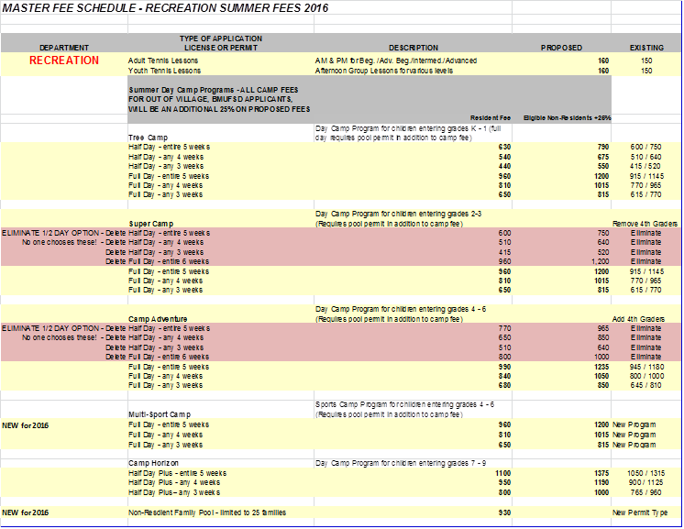

Schedule a Public Hearing for a Local Law to Amend Chapter 54 with Respect to Residency Requirements for Appointed Officers and for the Police Chief and Lieutenant

Upon motion by Deputy Mayor Pohar, seconded by Trustee Zirman, the Board voted unanimously to approve the following resolution as amended:
BE IT RESOLVED that a Public Hearing is hereby scheduled for the April 6, 2016 at 8:00pm Board of Trustees meeting to hear and discuss a proposed local law to amend Chapter 54 of the Code of the Village of Briarcliff Manor with respect to Residency Requirements for Appointed Officers and the Police Chief and Lieutenants.

Fire Department Membership – Rodriguez

The Board thanked Mr. Rodriguez for volunteering.

Upon motion by Trustee Zirman, seconded by Trustee DeRose, the Board voted unanimously to approve the following resolution:

BE IT RESOLVED, that the Board of Trustees of the Village of Briarcliff Manor hereby approves the membership of David Rodriguez to the Scarborough Engine Company.

Adjournment

Upon motion by Trustee Wilson, seconded by Deputy Mayor Pohar, the Board voted unanimously to adjourn the regular meeting at 8:44pm.

Respectfully Submitted By,
Christine Dennett
Village Clerk

