DRAFT MINUTES

Barrington Conservation Commission
July 22, 2014 7:00 PM
Proposed Carbaugh Subdivision, 2nd Crown Point Rd.
Joint Site Walk with Barrington Planning Board

PRESENT: John Wallace, Chairman
Pam Failing, Vice Chair
Anne Melvin
ABSENT:
Julia Guimond, Alternate
Ken Grossman
Alison Desmarais, Alternate
Marika Wilde, Alternate (joined at 8:00)
Fred Bussiere, Selectmen representative
Peter Sandin, Alternate
Glenn Gould, Alternate

- Guests: Kenneth Berry – representing the (Joe) Carbaugh subdivision, 2nd Crown Point Rd. Mr. Carbaugh was also in attendance.

The commission viewed the revised site for the proposed driveway for the new house lot that would be the result of the subdivision.

The commissioners did not discuss their positions on the subdivision; that will be done at the next regular meeting.

Respectfully submitted,
John Wallace

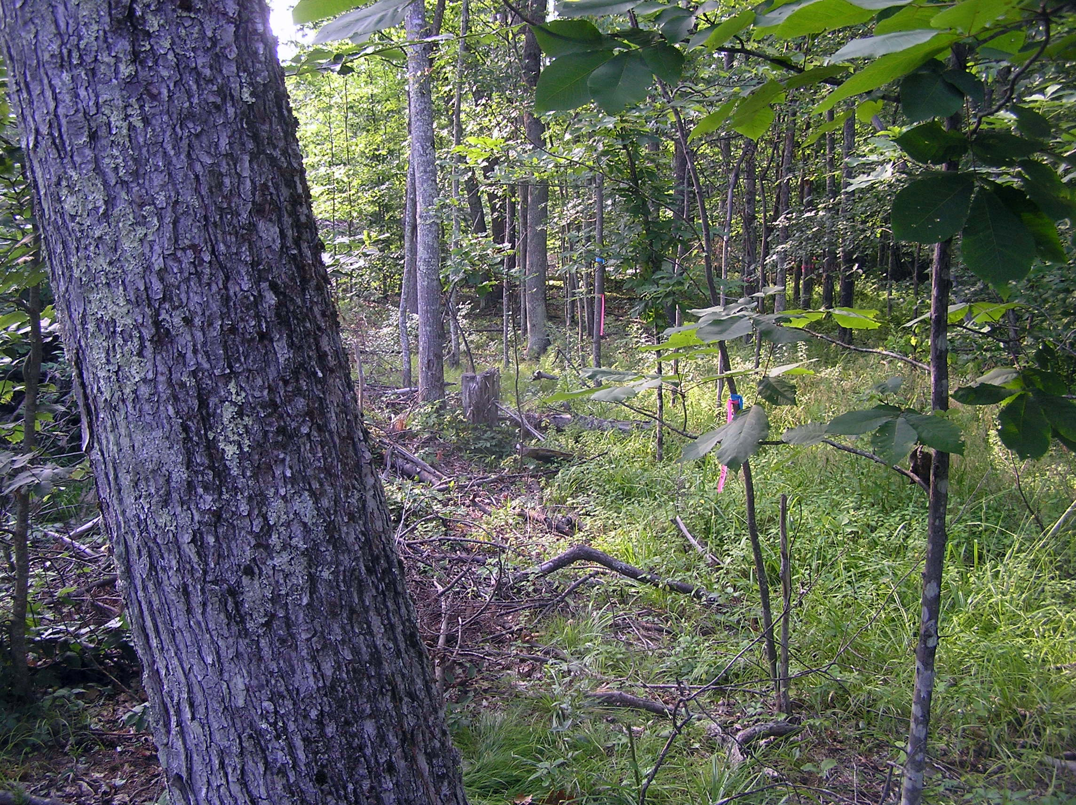

1 shows the view from the existing driveway, pretty much along the route of the proposed one

2 shows the view along the wetland (pink flagging), right along where the proposed driveway would go
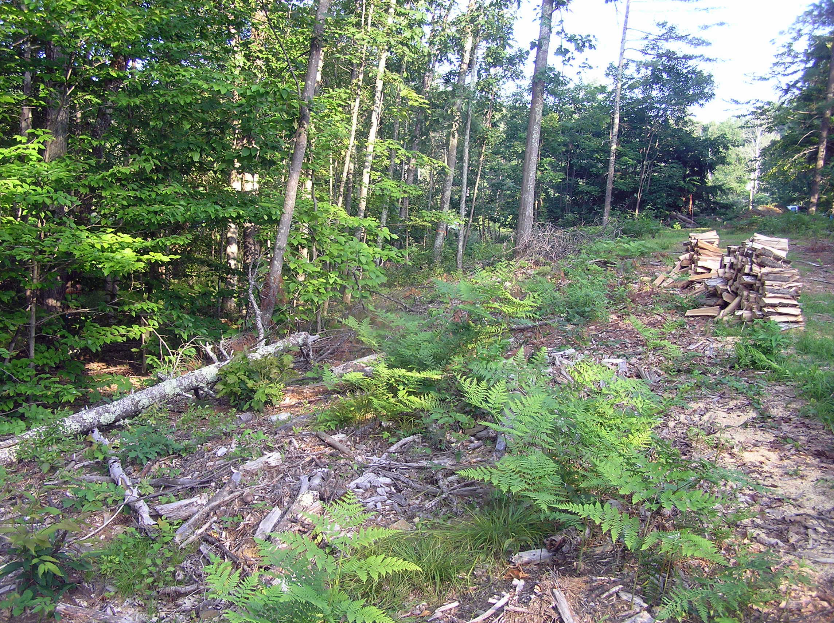

3 shows the view back towards the area of #2, again pretty much along the line of the proposed drive.

