Approved on May 17, 2012 - GMJ
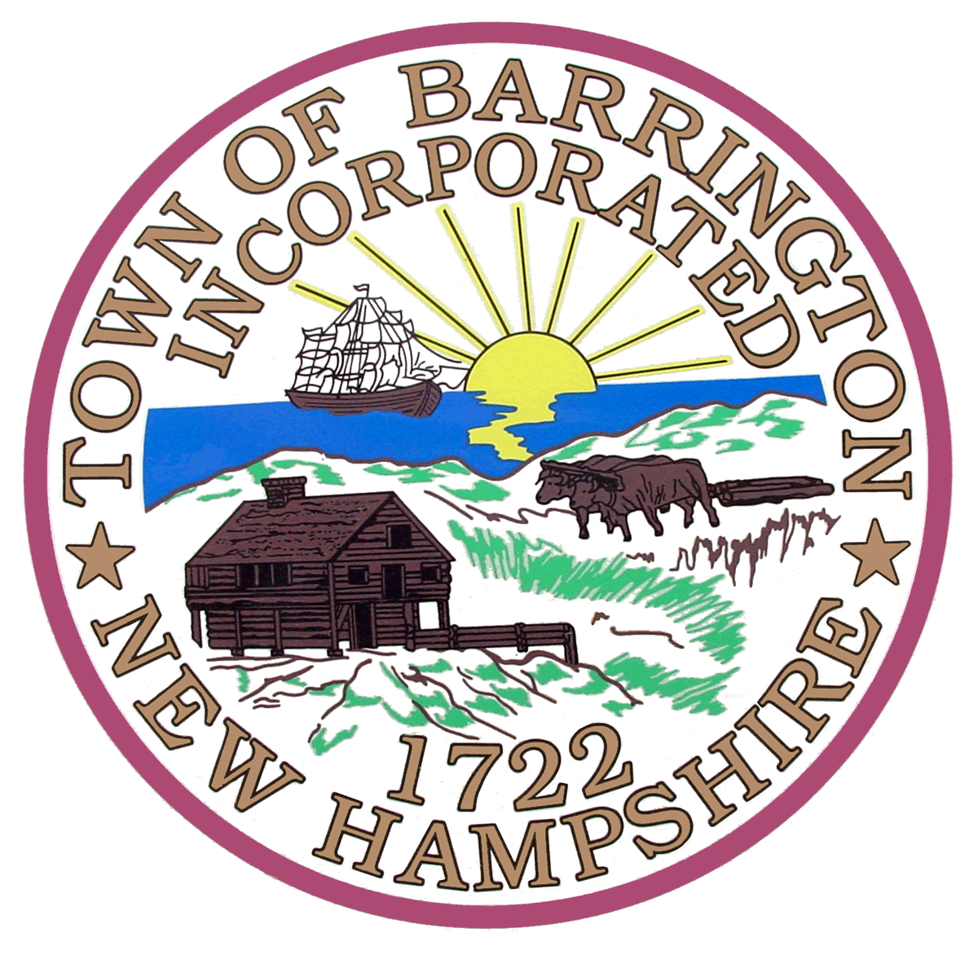

CONSERVATION COMMISSION
BARRINGTON PUBLIC LIBRARY
105 RAMSDELL LANE
BARRINGTON, NH

THURSDAY, APRIL 19, 2012
7:00 P.M.

MEETING MINUTES

PRESENT: John Wallace, Chair

Pam Failing, Vice-Chair
Anne Melvin, Alternate
Clayton Carl, Alternate

ABSENT: Peter Sandin, Alternate
Glenn Gould, Alternate

GUESTS: Michael Jensen; Barrington

STAFF: Gregory M. Jones, Transcriptionist

NOTE: THESE ARE SUMMARY ACTION MINUTES ONLY. A COMPLETE COPY OF THE MEETING AUDIO IS AVAILABLE A THE LAND USE DEPARTMENT.

CALL TO ORDER

Barrington Conservation Commission (BCC) Chair J. Wallace called the meeting of April 19, 2012 to order at 7:00 p.m.

1. DELEGATION OF VOTING MEMBERS

Chair J. Wallace confirmed the presence of members as stated above

2. GUESTS

A. Mathew Jensen – Office Building (Glass Lane)

Mathew Jensen approached the Board to discuss his proposal to construct a three-tenant office building on a 2.9 acre site located at 6 Glass Lane. Jensen informed the Commission that the lot is grandfathered from existing wetland buffer and previous wetland setback regulations as it was created in 1989. Jensen stated that the on-site wetlands were delineated in 2009 and informed the members that the property is within the watershed to Caldwell Brook, a proximate watercourse.

Vice-Chair P. Failing noted that the septic leach field appears to be within the 75’ State NHDES setback to wetlands.

Upon review of the application and supporting materials, as well as the Town engineering consultant’s April 18, 2012 technical review letter, the Board offered the following comments:

- Confirm the town engineering consultant recommendation to treat sheet flow by installation of deep sump catch basing with oil/water separator.
- Investigate the use of a rain garden treatment system and other Low Impact Development measures that may be used at the site
- Ensure protection of on-site wetlands during construction
- Surveyor should re-flag on-site wetland boundary to ensure against encroachment during construction
- Snow removal activities should be conducted so as not to allow snowmelt to enter wetlands directly and storage location should be noted on final plans.

Chair J. Wallace stated that he will transmit the Commissions comments to the Planning Board at the time of public hearing.

3. MINUTES REVIEW AND APPROVAL

A. Conservation Commission Meeting Minutes and Executive Session Minutes of April 5, 2012

C. Carl made a motion to table the Conservation Commission Meeting Minutes and Executive Session Minutes of April 5, 2012. A. Melvin seconded the motion which passed unanimously with a vote of four (4), to zero (0) in favor.

4. COMPLAINTS

There were no complaints

5. OLD BUSINESS

A. Purchase of Leahy land (abuts SATWaSR): 42 acres

Chair Wallace informed the Commission that the appraisal is forthcoming.

B. George Calef: interested in protecting ~300 acres along Isinglass End of March, $378,240.20 in
conservation fund, anticipate ~ $17,000 from 2011

A. Melvin made a motion to move from the regular meeting session to executive session considering the upcoming discussion involving the acquisition/sale of property. C. Carl seconded the motion which passed unanimously with a vote of four (4), to zero (0) in favor.

A. Melvin made a motion to move from Executive Session to the regular meeting session. C. Carl seconded the motion which passed unanimously with a vote of four (4), to zero (0) in favor.

C. New co-occurrence map. Need more revision? What to do with it?

Chair J. Wallace opined that discussion on this item should wait until the new digital tax map information is available for review. The Board agreed.

D. SATWaSR Management Plan – Need more revisions – What to do with it?

The Commission agreed that the plan must be more thoroughly reviewed by members. The Commission agreed to review the plan and come to the next meeting with suggestions for further updates.

E. Proposed sale of part of Clark-Goodwill Property to Turbocam

Chair J. Wallace informed the Commission that there are no updates for this item at this time.

6. NEW BUSINESS

A. Planning Board updates

    - Convenience store/gas station (Rte. 125) – cont’d to May

The Commission had no additional comment on the application at this time.

    - Office Building (Glass Lane)

See Section 2, Guests, above

    - Warehouse and office, Midpoint Properties (Rte. 4)

The project was conditionally approved by the Planning Board on March 3, 2012.

B. Report on “Saving Special Places” workshop: John, Anne

The Commission agreed to table this item to the next meeting.

C. Hosting of Con Comm web site

There was nothing to report at this time.

D. Line item in budget for conservation easement monitoring has been halved, to $2200

This item was discussed under the “Committee Reports” section of the agenda. See below.

7. ANNOUNCEMENTS/CORRESPONDENCE

A. DES

There was nothing to review at this time.

B. Hike/letterboxing on Town Forest, May 6

Chair J. Wallace informed the members that the Hike/letterboxing event with be held on May 6, 2012 at the Barrington Town Forest.

Vice-Chair P. Failing announced the possibility of working with a local small business owner to utilize town conservation lands for harvesting maple syrup. Failing informed the Commission that this business owner has offered to pay a fee for utilizing these lands and would like to discuss the possibility in the future. Chair J. Wallace stated that the lands may be worth hiking to evaluate the existing maple tree stands.

8. EASEMENTS

A. White Crest Conservation easement deed contains errors (with town counsel)
There was nothing to report at this time.

B. Remediation of SATWaSR violation

Chair J. Wallace informed the Commission that he visited the remediation site for the violation abutting the SATWaSR conservation easement. Wallace noted that remediation work in the impacted area is apparent.

9. COMMITTEE REPORTS

A. Natural Heritage Committee

Chair J. Wallace informed the Commission that the Natural Heritage Meeting will meet on May 4, 2012.

B. Other meetings – Town Forest Task Force, SATWaSR Stewardship group, BOSC, ORLAC, IRLAC, Water Resources, ORWA, Cochecho River WA, etc.

There was nothing to report at this time.

C. Line item in budget for conservation easement monitoring has been halved, to $2200

Chair J. Wallace recused from discussion.

After some discussion, the members agreed that 2012 conservation easement monitoring endeavors should be completed using the $2,200.00 allotted for this task. Members agreed that a list of town owned conservation easements including acreage and last time of official monitoring by BCC must be generated in order to prioritize 2012 monitoring. The group agreed that larger properties may require additional funding to complete and therefore a prioritization of existing lands is necessary. The group agreed to contact the Strafford Regional Planning Commission to retrieve information which may not be readily available at the Land Use Office.

10. MINUTES OF TOWN BOARDS

A. Selectmen: 10/17 & 10/24

Chair J. Wallace presented two sets of Board of Selectmen minutes for review.

B. Planning Board

The Planning Board minutes of April 3, 2012 were supplied for review.

C. ZBA

There was nothing to report at this time.

D. NHC

There was nothing to report at this time.

11. NEXT SCHEDULED MEETING:

The next scheduled meeting of the Barrington Conservation Commission is scheduled for May 3, 2012 at 7:00 pm in the Barrington Public Library.

C. Carl made a motion to adjourn the Conservation Commission meeting of April 19, 2012 at 9:40 p.m. Vice-Chair P. Failing seconded the motion which passed unanimously with a vote of four (4) to zero (0) in favor.

Respectfully Submitted,

Gregory M. Jones
Transcriptionist

